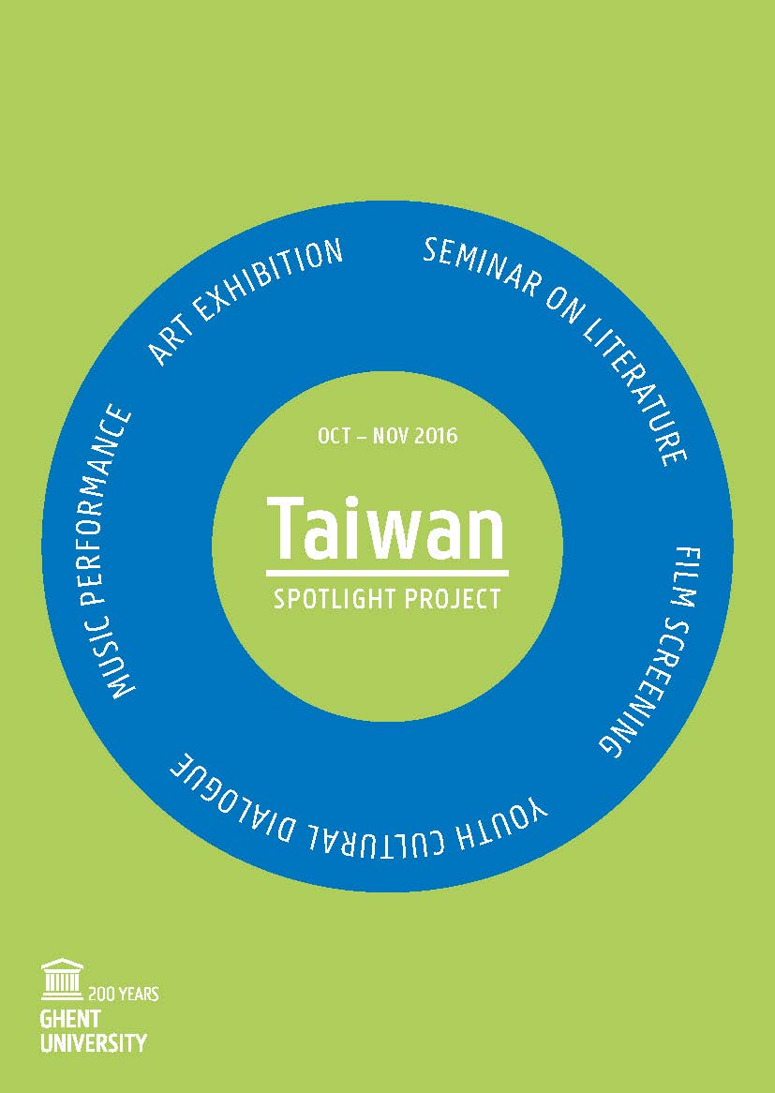
Concert
Soprano Lu Yu Cheng

Accompanied on piano by
Mr. Ivo Piscevic

16 November 2016

Convention Center “Het Pand”
Onderbergen 1, 9000 Ghent
Programme

18:00 – 19:00
Entrance

19:00 – 20:00
Official opening of the concert
- Welcome remark by Prof. dr. Luc Taerwe, Director China Platform, Ghent University
- Introduction about the recital by Mrs. Lu Yu Cheng
- Recital by Mrs. Lu Yu Cheng, accompanied on piano by Mr. Ivo Piscevic
- Closing word by Mrs. Inge Mangelschots, Coordinator China Platform, Ghent University

20:00 – 21:00
Closing reception
Soprano: Lu Yu Cheng
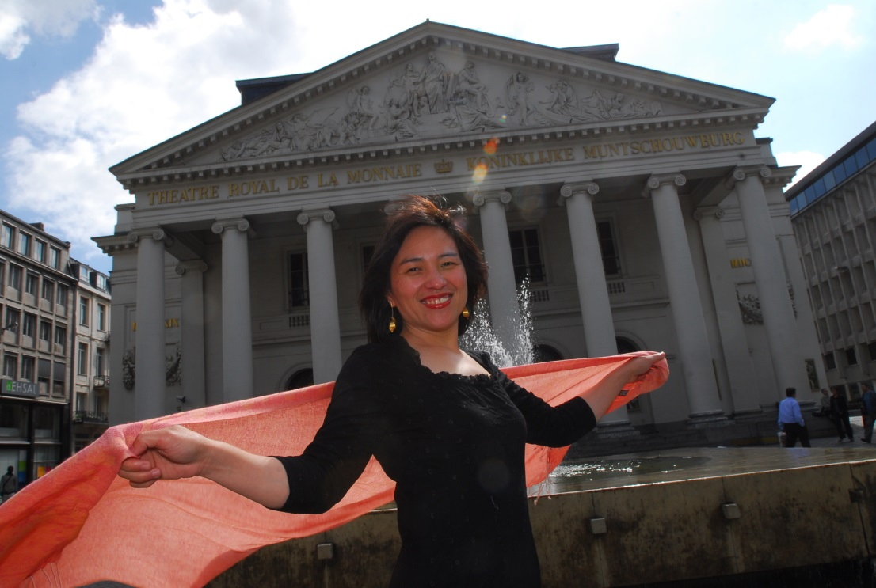

Soprano: Lu Yu Cheng

Lu Yu Cheng was born in the Taroko tribe of Taiwan. Surrounded from her childhood by music and singing, she decided to study music at the Taiwan Normal University (Shih Ta) of Taipei. Keen to better discover the western music, she arrived in Europe in 1994 and continued her studies in Amsterdam, Paris and Brussels.
Lu Yu Cheng starts her singing career in the National Experimental Choir of Taiwan and performs concerts in Taiwan and the USA.
Passionate by classic and romantic music, she performs with several ensembles like the Chœur de Chambre de Namur, Chapelle des Minimes, Laudantes Consort, Arte Vocale and sings as soloist at the Liège Opera, at the Studio Opera of the Monnaie (Brussels), at the “Solistes au Domaine” festival of Brussels and has given lots of recitals in all over the Europe.
She is presently a singing teacher for instrumentalists in the Royal Conservatory of Brussels.

Piano: Ivo Piscevic
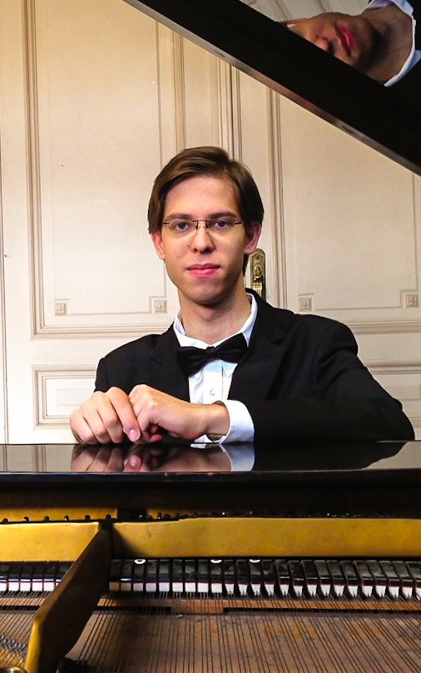
Piano: Ivo Piscevic

Ivo Piscevic studied Piano, Music Writing and Orchestral Conducting in many Conservatories and High Schools in Luxemburg, Paris and Brussels (Conservatory of Luxemburg, Ecole Normale Alfred Cortot, Schola Cantorum in Paris and Royal Conservatory of Brussels). He gets his Superior Degree in piano in Schola Cantorum with mention “Very Good“ in 2013.
Next to his piano studies with Daniel Blumenthal, he is the accompanist of the singing class of Lu Yu Cheng.

With the support of the Ministry of Culture
of the Republic of China (Taiwan)

