**TAIWAN BEATS IS GOING TO ROCK CMW 2017**

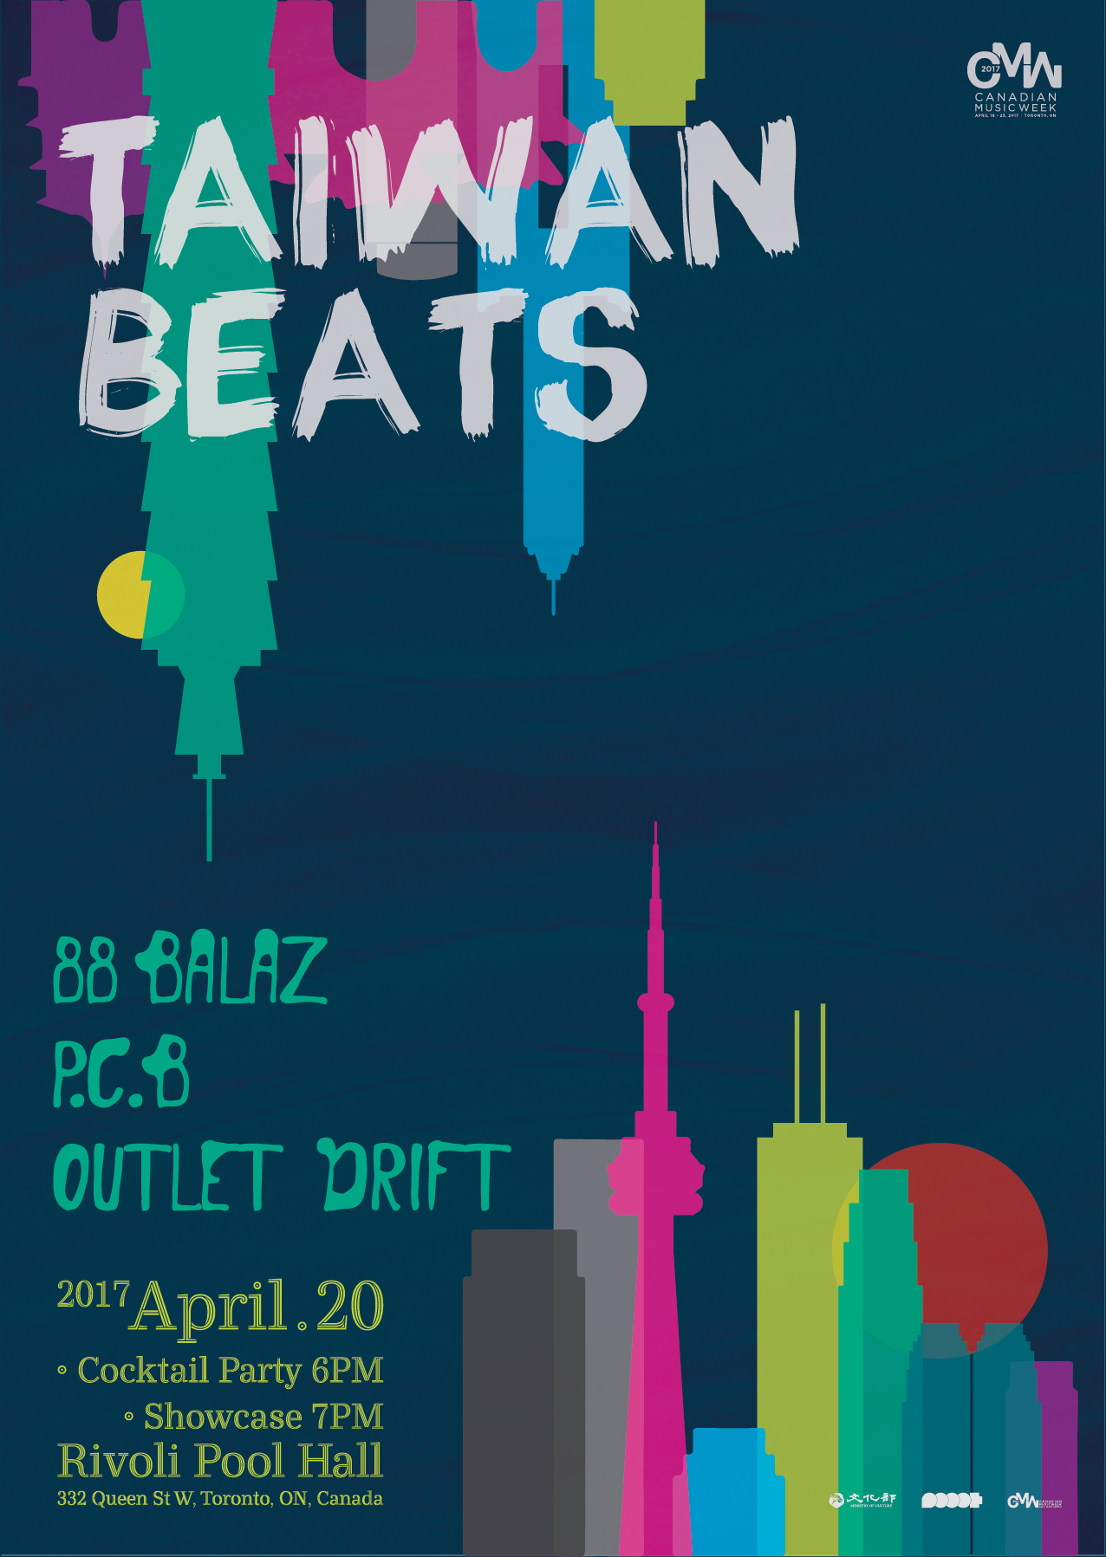

**EXCLUSIVE SHOWCASE AT THE RIVOLI**

**ON APRIL 20TH**

**with 88 BALAZ / P.C.B. / OUTLET DRIFT**

**Cocktail Reception:** 6:00 pm

**Showcase:** 7:00 pm

Taiwan Beats is bringing an exciting lineup of bands to the Rivoli on Thursday, April 20th for an exclusive showcase during Canadian Music Week.

The showcase, aptly titled **Taiwan Beats**, is highlighting three bands on the lineup, including bluesy garage band, **88 Balaz**, Indigenous group, **Outlet Drift**, and electro-indie outfit, **P.C.B**. See complete details below.

**88 Balaz** have been rousing audiences and sparking interest in locals and expat crowds alike since they formed around 1996. Wielding a battered acoustic and usually nursing a can of Beer, singer AH-Chang brings listeners into his songs that unfold like dreams and fables. Accompanied by BLUEZHIN's raw guitar solos and Guan Ling and 'Dongyo`s punky drums & bass.

88 Balaz become a bluesy garage band with just enough local *taike* intensity, but left to focus on 88 Balaz. While the band is credited as winning the biggest rock-band competition in taiwan-----Ho-Hai-Yan Indie Music Awards, Golden Indie Awards



Known for their energetic stage performances, 88 Balaz attract large crowds at festivals and live house events alike. Between songs, Ah-Chang engages the audience with a straightforward sincerity, and then goes nuts on his acoustic when the band sparks up. Guang ling and drummer keep a cool steady rhythm throughout the set before Chen How ends up doing a patented somersault solo leaving his posterior upright! Ever since coming out on top at the 2001 Ho-Hai-Yan battle of the bands at Fulong Beach, 88 Balaz have had huge festival turnouts with excited punks and average concert-goers eager to see the antics. The band also made their Japan & Beijing debut in early 2009, hitting up several well know rock clubs.

The founder of the Spring Scream music festival ,Wade, has made a comment on the 88 Balaz：「They Totally rocked!!!」

[www.facebook.com/88balaz](https://www.facebook.com/88balaz/)

[www.youtube.com/user/88balaz](https://www.youtube.com/user/88balaz)



**Outlet Drift** is comprised of three Indigenous Taiwanese youths from Taitung that love to jam together, united by their shared love of modern and avant-garde rock and grunge music. Once lost and under the influence of other cultures, they have finally found their identity in their own indigenous culture and through music are hoping to make an emotional impact. Thumping double bass drums, grungy bass and psychedelic guitar sound as if a little boy is running and screaming through a creepy, foggy woods. This is a band that blends traditional Indigenous Taiwanese tunes with experimental folk, grunge, psychedelic and metal. Clad in traditional Amis (indigenous clothing), their live shows are an audio-visual experience that you won’t forget.

[www.facebook.com/outletdrift](https://www.facebook.com/outletdrift/)

[www.youtube.com/user/OutletDrift](https://www.youtube.com/user/OutletDrift)

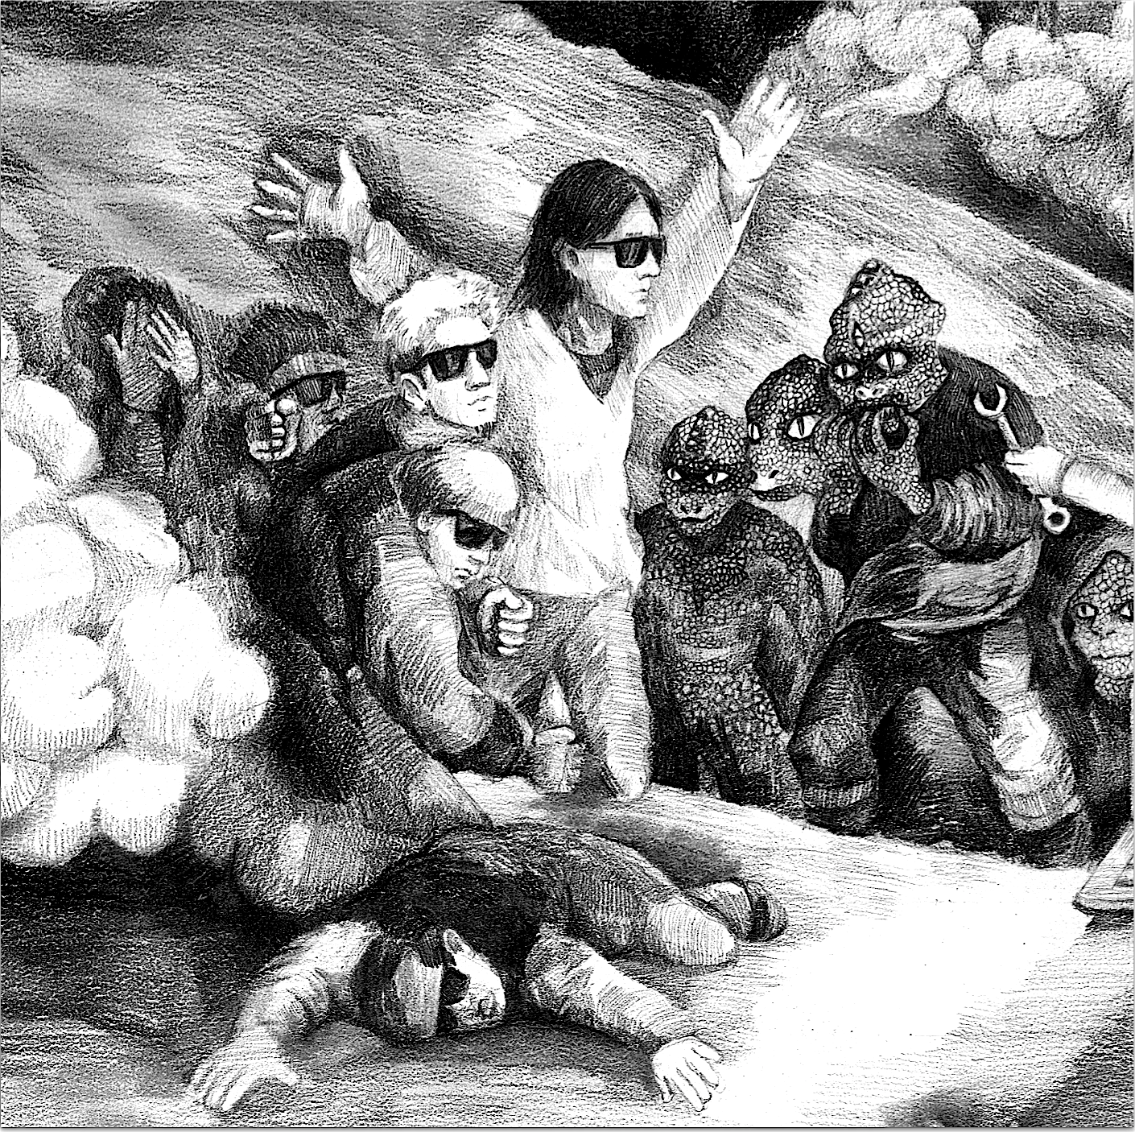

**P.C.B.** delivers a different vibe to the showcase,sampling 8 bit sounds and graphics from Nintendo games, creating tracks through styles that range from Electronic, Techno, Drum and Bass to Dubstep. They mix these genres together and take it to the dancefloor, where their sound can be defined as electro indie.

[www.pcb.com.tw](http://www.pcb.com.tw/)

[www.facebook.com/PCBrother](https://www.facebook.com/PCBrother/)

[www.youtube.com/channel/UCo0C_TKEpjTsnkT897QEIkQ](https://www.youtube.com/channel/UCo0C_TKEpjTsnkT897QEIkQ)

**TAIWAN BEATS SHOWCASE INFO:**

Thursday, April 20

The Rivoli

6:00 pm: Doors and cocktail reception

7:00-7:40 pm: Outlet Drift

7:55-8:35 pm: 88 Balaz

8:50-9:30 pm: P.C.B

More info: [www.cmw.net/music/shows/taiwan-beats](https://cmw.net/music/shows/taiwan-beats/)

**CMW SHOWS:**

88 Balaz – April 19 @ Stop Drop & Roll – 9:00 pm

[www.cmw.net/music/artists/88-balaz](http://www.cmw.net/music/artists/88-balaz)

Outlet Drift – April 21 @ Stop Drop & Roll – 1:00 am

[www.cmw.net/music/artists/outlet-drift](http://www.cmw.net/music/artists/outlet-drift)

P.C.B. – April 22 @ The Painted Lady – 2:00 am

[www.cmw.net/music/artists/p-c-b](http://www.cmw.net/music/artists/p-c-b)