www.contacttaiwan.tw
For better working, living and business experiences
Contact Taiwan
Simply
The best location to pursue a career in the Asia-Pacific region.
Welcome to Taiwan to fulfill your life and career dreams! Taiwan connects your work and life to the world and future.
Contact Taiwan is a government website that seeks talented professionals worldwide to live and work in Taiwan. We offer global professionals, and overseas students, a ONE-STOP employment matchmaking service, providing comprehensive guidance for working, living and investing in Taiwan.

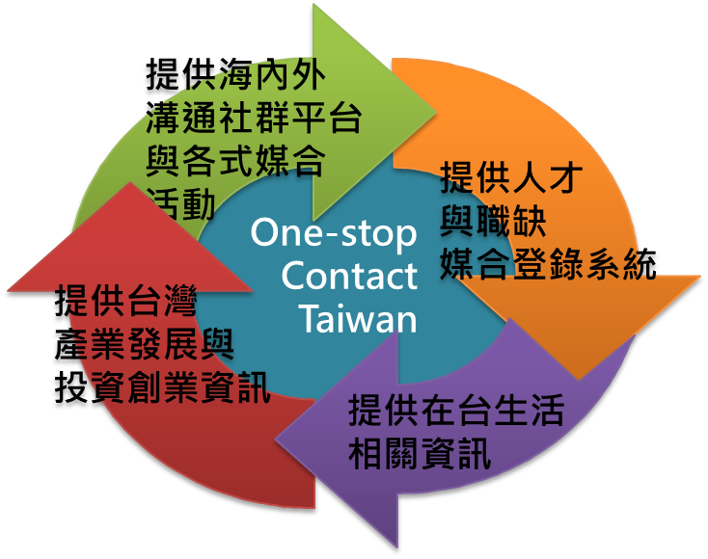
Contact Taiwan provides a one-stop service for global professionals, domestic enterprises and foreign investors. You can view success stories of global professionals working and living in Taiwan on our website. From our homepage, you can find related information with ease.

- Contact Taiwan provides information about employment, visa application and life in Taiwan for global professionals.
- Contact Taiwan provides foreign professional matchmaking recruitment services for domestic enterprises.
- Contact Taiwan provides information about industrial advantages, investment opportunities and incentive programs in Taiwan for foreign investors.
- Want to know more about the friendly employment environment in Taiwan?
Communication channels through social media and recruitment events
Employment and recruitment matchmaking service
An island nation located within the subtropical zone, Taiwan enjoys warm weather all year round. Its major cities are among the most livable in Asia:
Information about living in Taiwan

Information about industrial advantages and investment opportunities in Taiwan

Taipei city is ranked 7th while Kaohsiung city is ranked 11th in the “2015 Location Ratings for Expatriate Living Conditions” published by ECA International, the world's leading provider of knowledge, information and technology for the management and assignment of employees around the world.

Foreigners living in Taiwan are mostly satisfied with the island’s convenience and public security:

- Healthcare – Taiwan has one of the world’s best national health insurance systems. The nation has gained a good international reputation for state-of-the-art medical facilities and low-cost treatment.
- 2014: The Richest web, Canada, names Taiwan "The country with the best healthcare system".
- 2014: CNN hails Taiwan's medical achievements.

- Network communication – Taiwan’s ICT industry leads the world. You can enjoy free Wi-Fi in major cities in Taiwan. According to a CNN report in 2015, Taiwan is one of the first places in the world to offer free Wi-Fi on a broad scale, using more than 4,400 hotspots. The Internet penetration rate is high in Taiwan; with more than 80% of households having high-speed broadband access to the Internet.
- Cuisine – Taiwan’s cuisine is famed throughout the world for its abundance of enticing dishes. From multifarious cooking styles to snacks referred to as “small eats”, every dish blends unique qualities.
In addition to aboriginal-style cuisine, Hakka, Taiwanese and Mainland Chinese home cooking and foods, Taiwan also serves up Japanese, Korean, Indian, Southeast Asian, European and American dishes, making the island a culinary paradise.
- Transportation and convenience – Getting around Taiwan is easy thanks to a complete and integrated transportation infrastructure that incorporates MRT systems, high-speed rail, Ubike, railways, highways, airports, harbors and other forms of public transport. You can take a trip to the beach, mountains and village within a short period of time. Besides, there are 24-hour convenience stores throughout Taiwan, with an average of one store per 2,000 people. Taiwan has the world's highest density of convenience stores, which make the metropolitan life more convenient.

- Education – Expatriates can choose to send their children to international schools. Such schools may offer education pathways and curriculums that are similar to those in your home country.

- Advantages of industrial development and investment opportunities in Taiwan
Taiwan's technology development and manufacturing industries have gained global competitive advantages. Many of Taiwan’s manufactured products are ranked highly in the international market. Taiwan accounts for more than 70% of the global supply of semiconductors and photovoltaic and ICT products.

Taiwan’s IC foundry output makes up 67.4% of the global market share. This industry, along with downstream packaging and testing, are ranked first in the world. Output of IC design and TFT-LCDs is ranked second in the world, with the former making up 21.5% and the latter a high proportion of global output.
In addition, Taiwan ranks among the top three in the world in output of PC products.

Taiwan’s friendly investment environment is also ranked highly by many noted international rating agencies. For instance, Taiwan ranked 15th among 140 countries in the “2015-2016 Global Competitiveness Report” published by the World Economic Forum, and 11th in the “2016 Doing Business Report” released by the World Bank. Moreover, Taiwan remains the world's 14th most investor-friendly nation in 2014-2018 based on the “Business Environment Rankings” reported by the Economist Intelligence Unit.

Simply put, Taiwan has an outstanding environment for self-realization by global professionals and entrepreneurs:
- Taiwan has the largest crowdfunding platform in Asia, assisting entrepreneurs to raise funds by matching creative proposals with resources.
- Taiwan is famous for its innovative research and development vitality. With a superior high-tech infrastructure and R&D professionals as well as high-quality product and service chains, Taiwan is an outstanding R&D hub in the Asia-Pacific.
- Taiwanese manufacturers have accumulated rich production experiences, agile innovation capabilities and international strategies to adapt to the rapidly changing global market. Taiwan plays a key role in the international supply chain, shaping it into an innovative hub for high-quality products.
- Taiwan has a mature and stable capital market which encourages participation by international funds for overseas distribution. It can be regarded as an international manufacturing fundraising center and a base for multinational strategic alliances.

Contact Taiwan provides information on key industries for global professionals to understand and utilize the advantages of its industrial development:

- Productivity 4.0
- High-End Processing Equipment
- Advanced Electronic Components
- Smart System Integration
- 5G and Advanced Communications

- Biotech Pharmaceutics and Medical Equipment
- Renewable Energy
- Product and User Experience Development
- Advanced and Innovative R&D
- International Financial Services

- Online employment matchmaking to assist you in finding work in Taiwan
Contact Taiwan offers an employment matchmaking service which identifies and connects with local companies wishing to employ highly skilled foreign professionals. This one-stop service helps to arrange job interviews between applicants and companies as well as communication support for both parties.
Want to learn more about Taiwan’s living and working environment, and industrial development? To gain an idea of what working and living in Taiwan is like, you can view many success stories of expatriates on Contact Taiwan.

For more information, visit Contact Taiwan
Contact details
Department of Investment Services, Ministry of Economic Affairs
TEL: 02-2389-2111
FAX: 02-2370-5565
Customer Service Center:
0800-888-070
Taiwan External Trade Development Council
TEL: 02-2725-5200 ext. #1963, 1965, 1966
FAX: 02-2725-5967
E-MAIL: contacttaiwan@taitra.org.tw

