INVITATION TO BID

Taipei Economic and Cultural Office (TECO) invites all interested parties to participate in the public bidding of the two (2) disposal motor vehicles.

Vehicle Unit | Make : Ford E150 Chateau  Engine No. : 76HB28047  Chassis No. : 1FMRE11W76HB28407  Piston Displacement : 4,600  Year Model : 2006 Color : Black  Mileage : about 84,500 km. | Make : Nissan Cefiro Classic Sedan  Engine No. : VQ20-101785  Chassis No. : CLFULEAA33-A25553  Piston Displacement : 2,000  Year Model : 2007 Color : Black  Mileage : about 101,400 km.
Unit Photos | 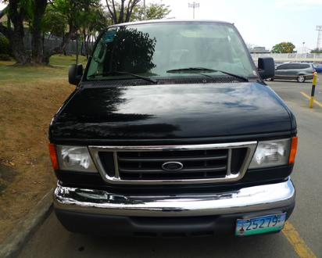  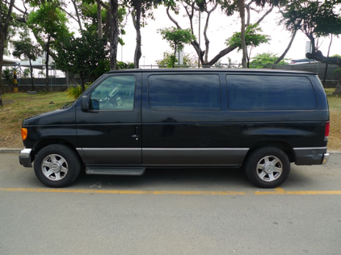 | 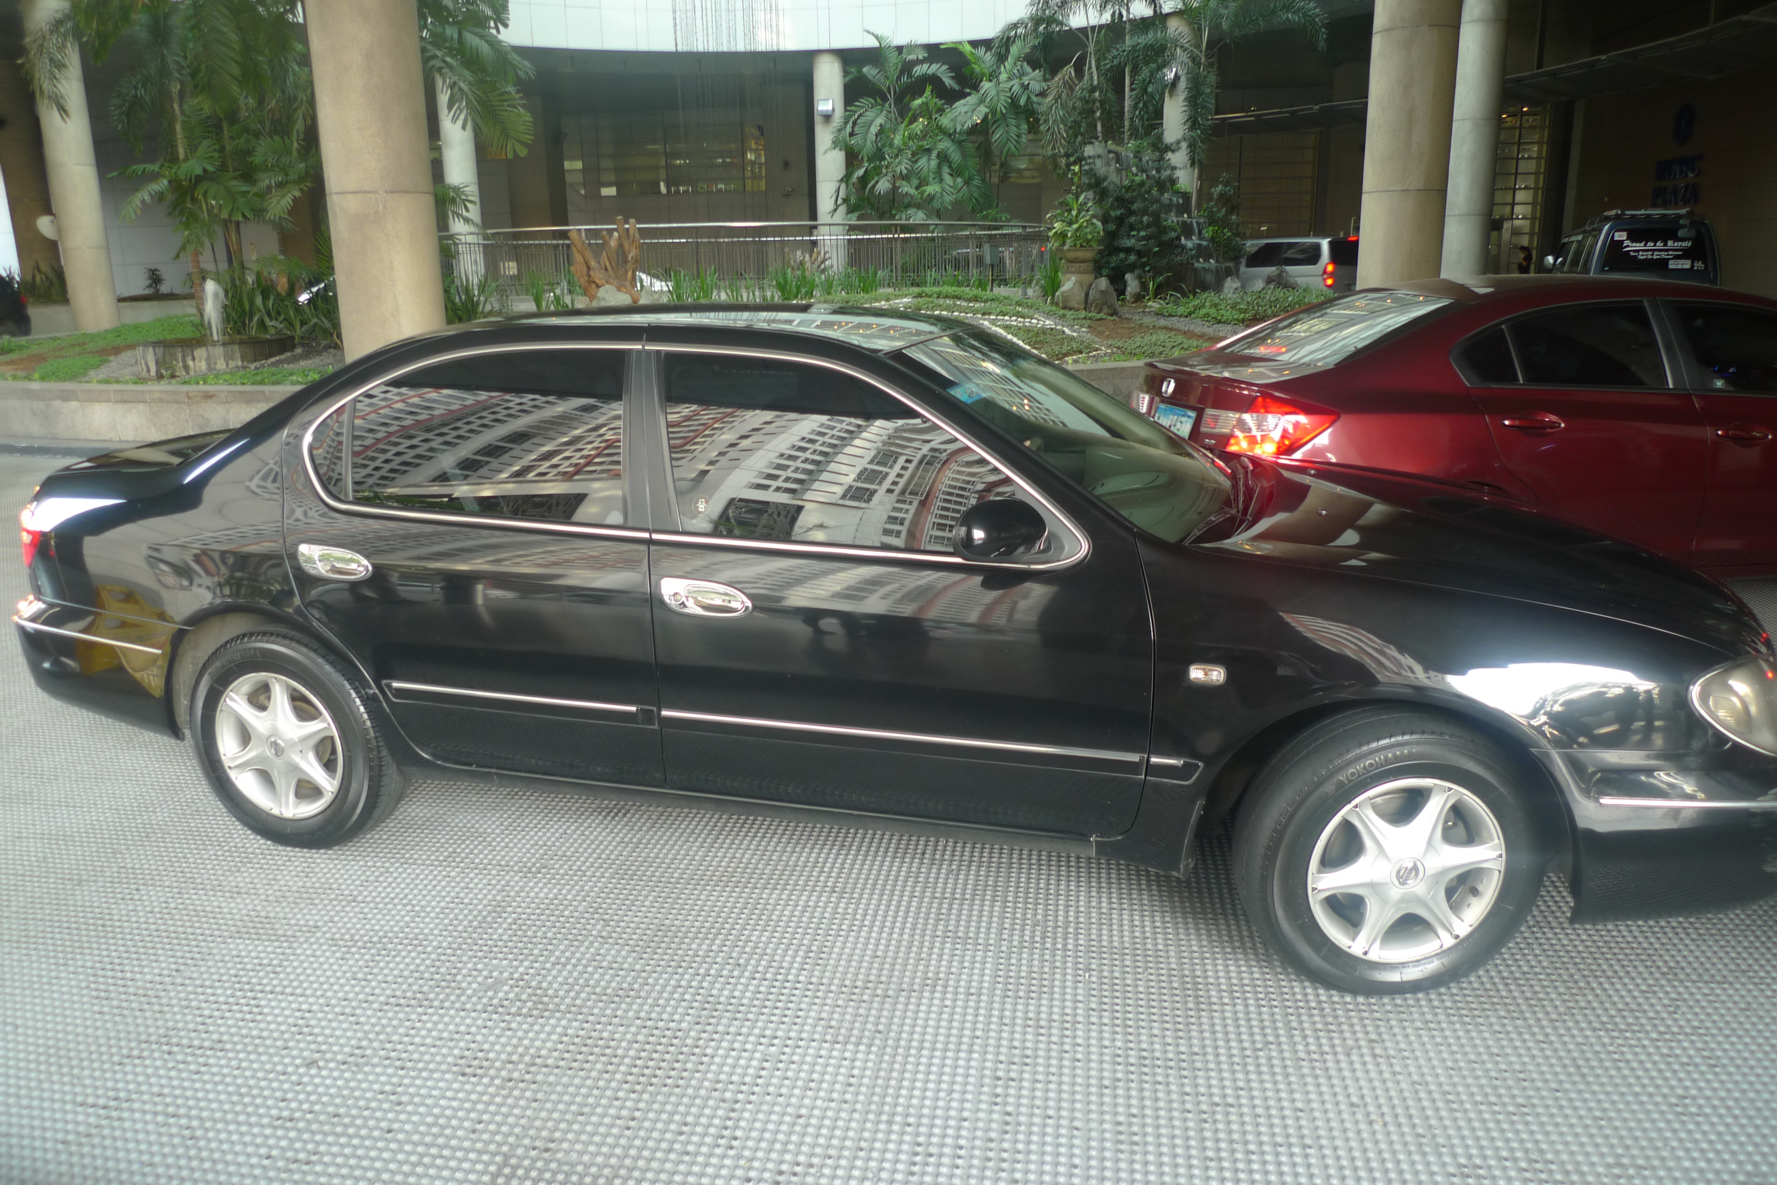  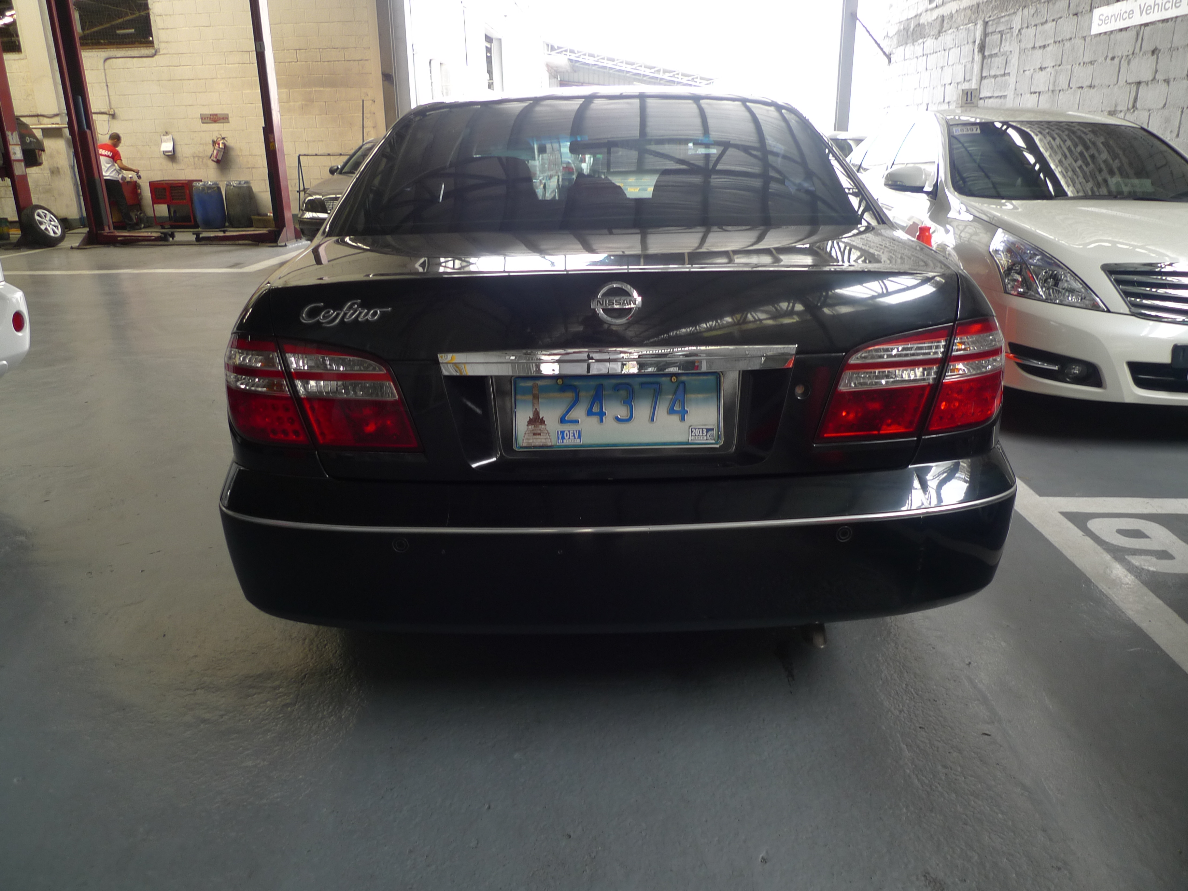
Floor Price | Php 150,000.00 (2 vehicles together for one price)
Bidder Form | Please submit the “Bidder Form” via Registered Mail, Email, Fax or Personally before 5:00pm February 21(Wed.), 2018 (see next page)  Address : 41Fl., Tower 1, RCBC Plaza, 6819 Ayala Avenue, Makati City  Tel : (02) 887-6688 ext. 136 (Ms. Teresa Go) or 137 (Mr. Richmond Lei)  Fax : (02) 887-7679  Email : teresa.tecoph@yahoo.com or informtecoph@gmail.com
Viewing/  Inspection | 10:00am~4:00pm, February 13 ~ 20, 2018 (working days only)  Contact Ms. Teresa Go or Mr. Richmond Lei
Bid Opening | Time/Date: 05:30pm., February 21(Wed.), 2018  Venue : Meeting Room, TECO
Minimum Bid | The minimum bid shall not be lower than the posted floor price for the two units
Notices:
- Caveat Emptor: the units shall be sold on “AS-IS, WHERE-IS” basis.
- The transfer of the tax-exempt imported motor vehicles to a non-privileged party is governed by Section 107(B) of the National Internal Revenue Code.
- The winning Bidder (Buyer) will be contacted and required to execute a Deed of sale and pay the full amount of bid at TECO within Seven (7) days.
- Upon completion of the payment at TECO and relevant applicable taxes and duties have been paid, the Buyer shall be the recipient of the purchased vehicles and required to transport the vehicles within Seven (7) days
- TECO reserves the rights to reject any or all the bids with or without cause.

