2016年越南菁英500臺灣留學專案
線上申請入學操作手冊
User Operating Manual
Online Admission for VEST-500 Project
ESIT Website: http://www.esit.org.tw

教育部菁英來臺留學辦公室
MOE Elite Study in Taiwan Project Office (ESIT)
----------------------------------------------------------
Chung Yuan Christian University
200, Chung Pei Road, Chung Li District, Taoyuan City,
Taiwan, R.O.C. 32023
Tel: +886-3-265-1295 | Fax: +886-3-265-1297
Website: http://www.esit.org.tw | Email: info@esit.org.tw

Content
A. Sign in 3
B. Sign out 3
C. Application Form _ Step 1: Financial Information 3
D. Application Form _ Step 2: Application Form 4
E. Application Form _ Step 3: Select Program 4
F. Application Form _ Step 4: Recommendation Letter 5
G. Application Form _ Step 5: Affidavit 6
H. Upload Application Document 7
I. Home 7
J. Send 8

- Sign in
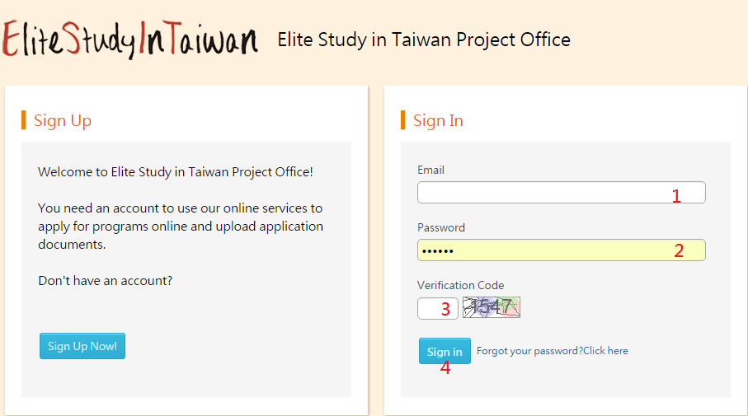
- Sign out
Click this button to log out the front desk directly.
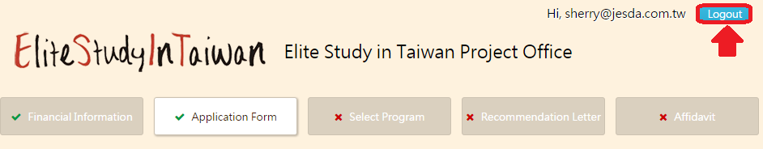
- Application Form _ Step 1: Financial Information
Prev: Return to Application recognizance book.
Next: Next to Step 2: Application Form.
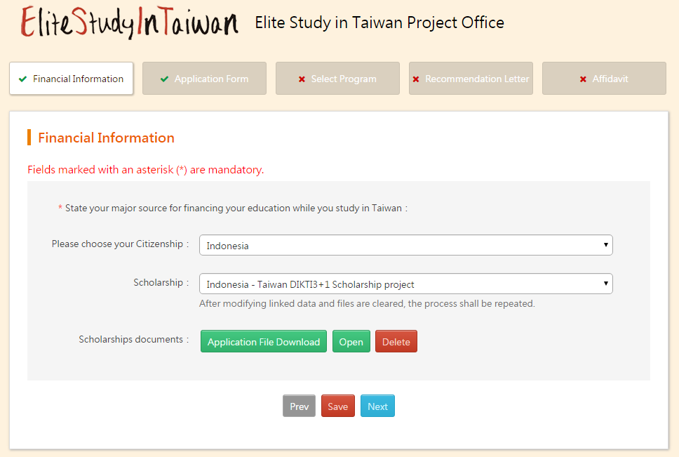
- Application Form _ Step 2: Application Form
Prev: Return to Financial Information.
Next: Next to Step 3: Select Program.
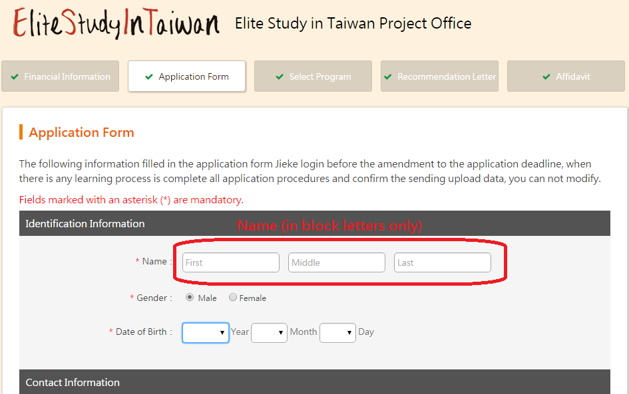
- Application Form _ Step 3: Select Program
When you join the program, our system will show the program on the right of the yellow box.
Prev: Return to Application Form.
Next: Next to Step 4: Recommendation Letter.
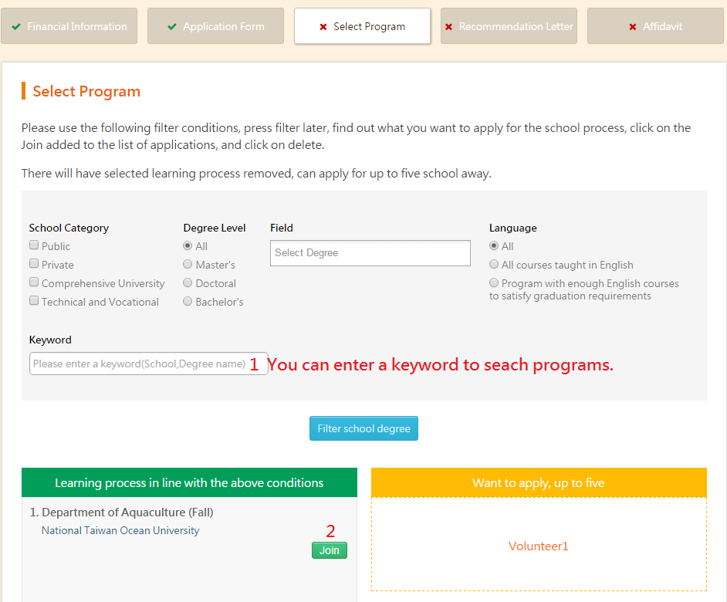

- Application Form _ Step 4: Recommendation Letter
There are two steps:
- You must to fill in information of two referees.
Prev: Return to Select Program.
Next: Next to choose referee for the program(s).
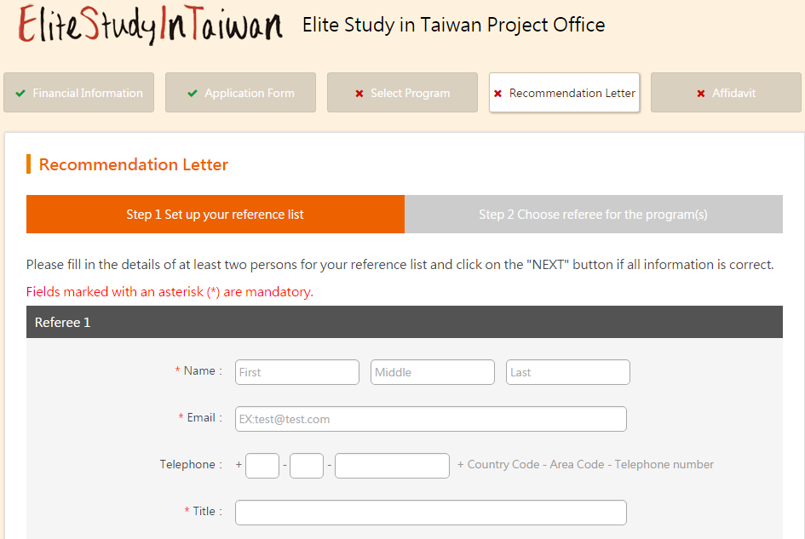
Add referee:
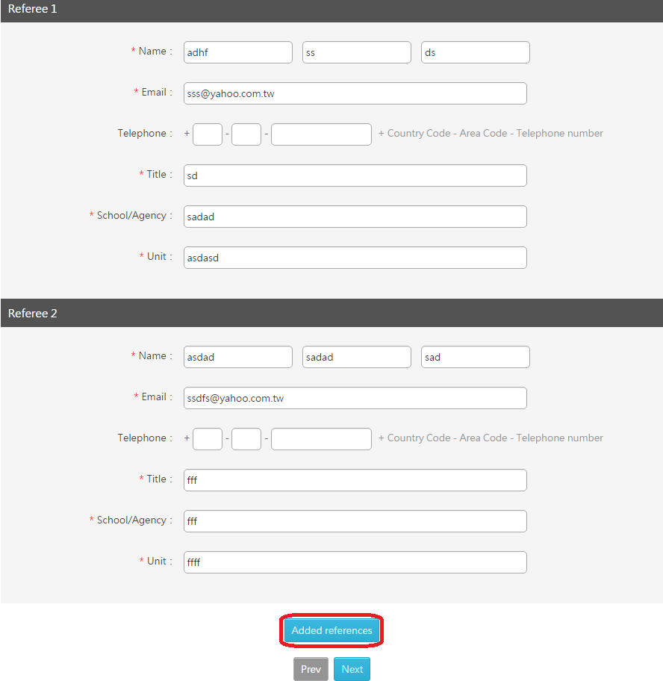
- choose referee for the program(s).
Prev: Return to set up your reference list.
Next: Next to Step 5: Affidavit.
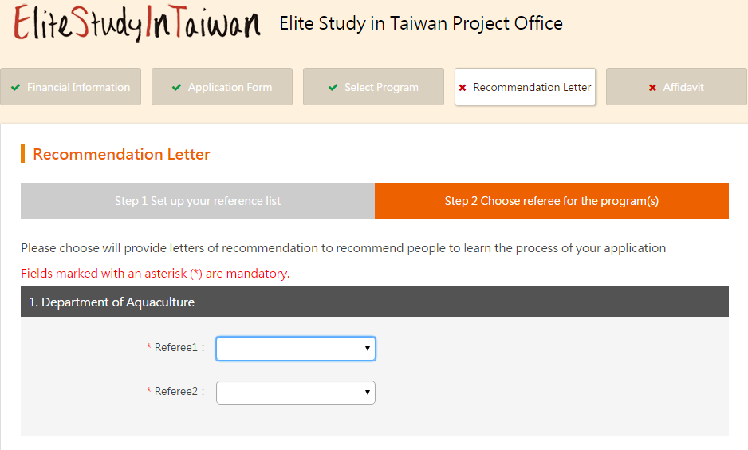
- Application Form _ Step 5: Affidavit
Prev: Return to Recommendation Letter.
Next: Upload Application Document
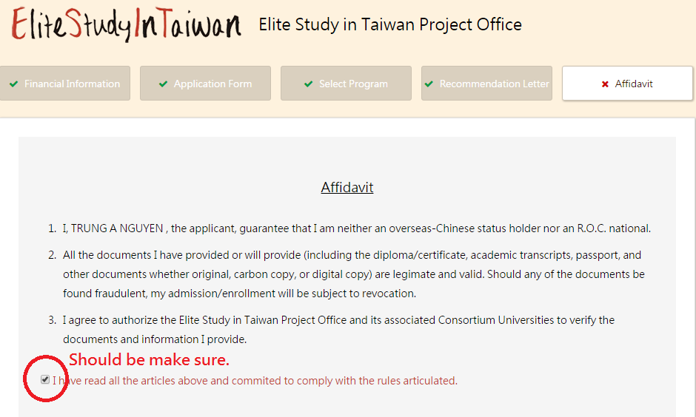

- Upload Application Document
You can upload application document on this page.
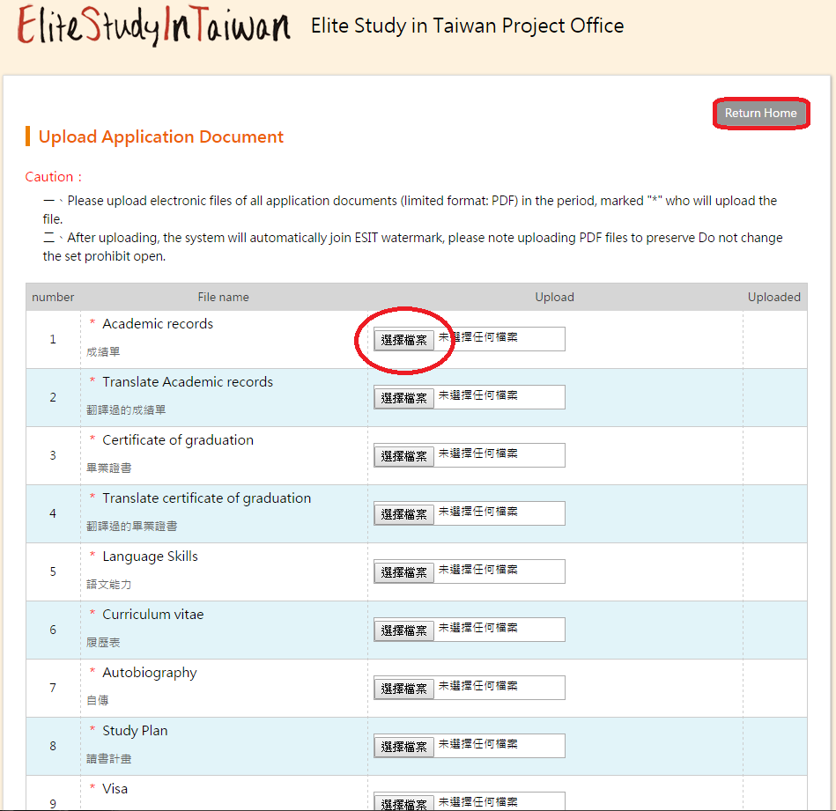
- Home
When you click the “Return Home” button, you will back to home page, as shown below. If you want to renew any information, you can click green button(s).
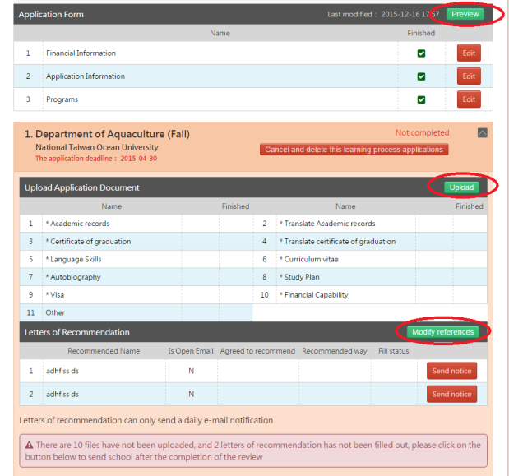

- Send
