- 2016.2.26-CfC (Cities for Cyclists) Cycle route map
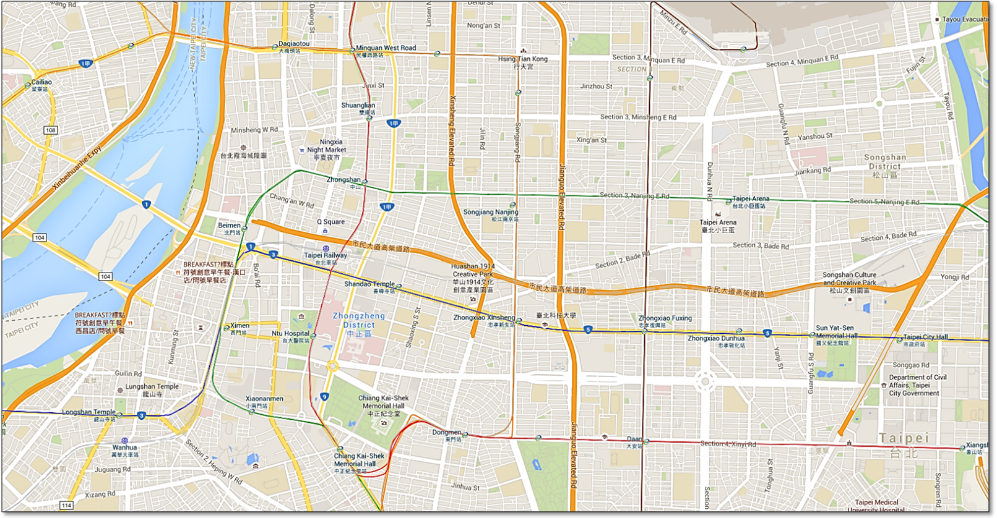
Map data @2015 Google
8

C

D
1
5
10
9
7
6
4
3
2

A

B

Attractions
Stopover points
Cycling route

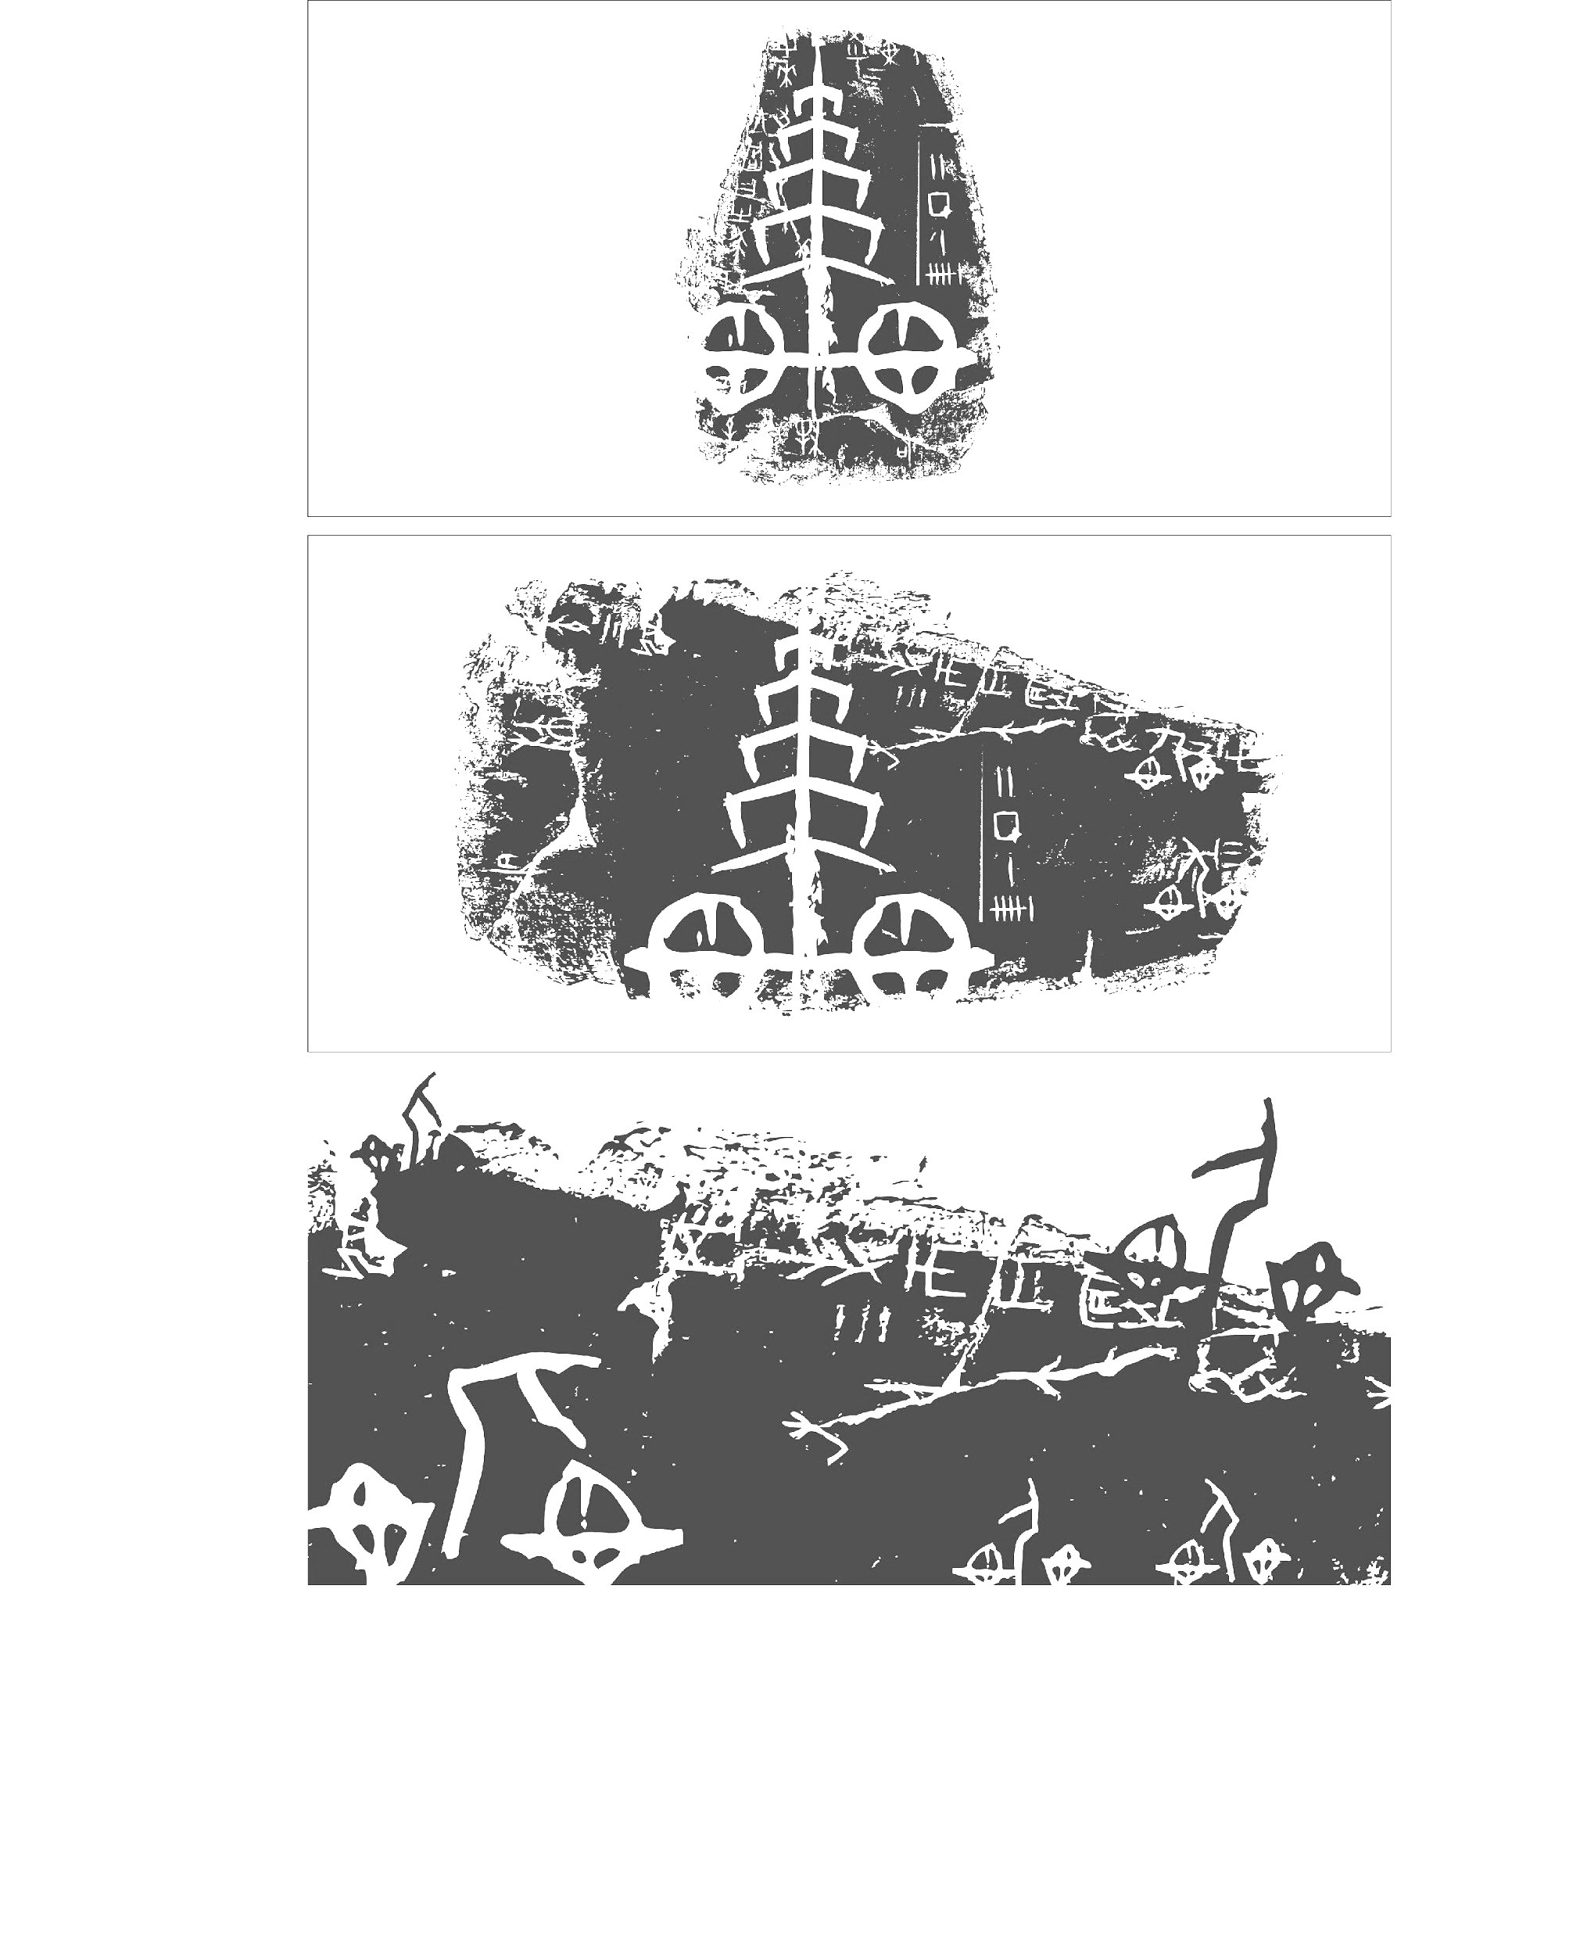
- Schedule
No. | Arr. | Dep. | Attractions | Journey
A |  | 09:00 | Taipei City Hall | 10min.
1 | 09:10 | 09:25 | Xinyi Assembly Hall(Si-Si Nan Cun) | 15min.
2 | 09:40 | 09:55 | Daan Park | 10min.
3 | 10:05 | 10:25 | QingTian 76(Ma Ting-Ying Residence) | 15min.
4 | 10:40 | 11:10 | National Chiang Kai-shek Memorial Hall:The National Theater & Concert Hall | 5min.
5 | 11:15 | 11:30 | Office of the President(Taipei Guest House) | 10min.
6 | 11:40 | 11:55 | A Visual Journey of Discovery of Taipei City, Then and Now(The Red House) | 5min.
7 | 12:00 | 12:15 | Nishi Honganji Square | 5min.
B | 12:20 | 13:30 | The historic Bopiliao area | 5min. | Lunch time
8 | 13:35 | 13:45 | Longshan Temple | 35min.
9 | Cycling along the riverside bike path
C | 14:20 | 15:20 | DaDaoCheng Theater |  | Workshop
10 | 15:20 | 15:50 | Dihua St. | 10min.
D | 16:00 |  | MRT Daqiaotou Station

- No.1─Xinyi Assembly Hall
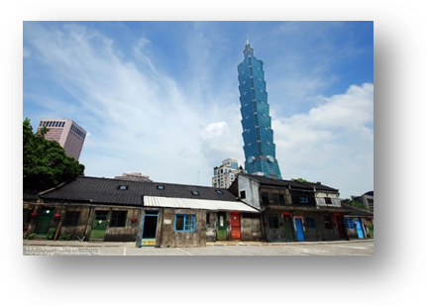 At a corner in Taipei’s high-end Xinyi District, a few low-rise houses sit closely together. These somewhat crowded buildings chronicled the tears and joy of veterans who migrated to Taiwan in the early days. This is the former siteof Taipei City’s Military Dependents’ Village, called the “Si-Si Nan Cun (The Village)”.
This Military dependents' villages are the embodiment of the historical and cultural transition. It later handed over to the Chinese Nationalist Government and a horde of mainland residents and soldiers retreated to Taiwan in 1949, the year which marked the end of the Chinese Civil War. Most of these villages were built in the late 1940s and 1950s to serve as provisional housing for Nationalist soldiers and their dependents from mainland China.
Due to the land development and the reconstruction of the military families’ quarters for the Xinyi Project Area, all residents of Si-Si Nan Cun (The Village) moved out in 1999. The buildings were destined for demolition. However, the former residents and members of cultural associations provoked a preservation movement for The Village and this gave birth to the Si-Si Nan Cun Culture and History Studio. The Cultural Heritage Evaluation Committee, Taipei City, considered The Village an “historic edifice”, and made a plan to preserve and rebuild four structures. On October 25, 2003, the Xinyi Public Assembly Hall and Cultural Park was inaugurated. It covers a ground area of about 137.2 acres with a buildings area of about 23.8 acres including the Special Exhibition House, Military Dependents Exhibition House, Display House and Community House, Central Square and Culture Park.

- No.2─Daan Park
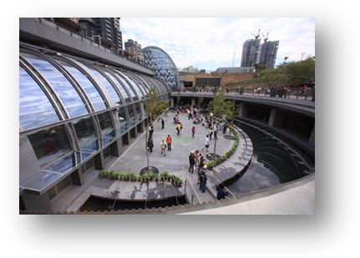 Taipei is a bustling, modern and vibrant city that truly never sleeps, and while these are all attributes that make Taipei an interesting place to visit, it can be a bit overwhelming. So if you need a break from the hustle and bustle of Taipei but you don’t the energy or time to venture out of the city, there is a haven in the middle of the city called Daan Park.
The park which covers a total of 259,293 square meters in area is Taipei’s largest park and is nearest the core of the city. Construction of the park began in 1985 in response to ever-increasing urban development. The park was finally completed and opened to the public on March 29, 1994. There is a nice amphitheater where you can watch concerts from local bands to the symphony orchestra. It’s a bit hit and miss as to what’s on and when, but if you do catch an event as the sun is going down, it’s really quite special.
The closest MRT station at the moment is Daan Park Station. Towards the north-west corner of the park is an “ecological pond” which has a variety of birds, turtles (including some monsters) and fish. Daan Park is an ecological park with a forest-like environment. Park roads are lined with trees such as camphor, cajuput, ficus and maples. Bushes and flower beds are planted throughout the park to help make the park into a lush, green space. The park is likened to the lungs of Taipei.

- No.3─QingTian 76(Ma Ting-Ying Residence)
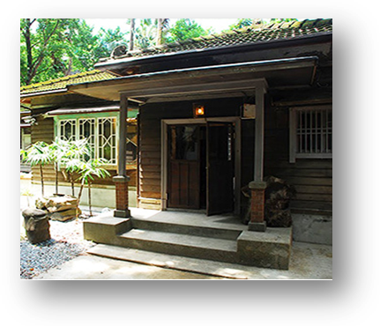QingTian 76 on No. 6, Lane 7, Qingtian Street initially was one of the residential houses built by a housing cooperation group of Japanese professors. The old Japanese-styled house was designed and built by Professor Masashi Adachi, and was completed in 1931. In 1945 the house became the residence of Professor Ting Ying H. Ma. Since 1945 up until 2006, the house had been home to the Mas. On May 2nd, 2006, the house was officially designated a Municipal Relics site through a Taipei Municipal Government Declaration. The wooden house is then named: “Japanese-styled Residential Building, National Taiwan University Professor Ting-Ying H. Ma’s residence”.
Professor Ma was the first Head of the Department of Geosciences in National Taiwan University. At QingTian 76 there is a standing exhibit of geological samples. This is in remembrance of Professor Ma, and also intended to further spread the knowledge of geology and extend geological education to the general public, so much so that we hope through this exhibit geosciences will become a daily life common sense, and the public will be better aware of the environment.

- No.4─National Chiang Kai-shek Memorial Hall:
The National Theater & Concert Hall
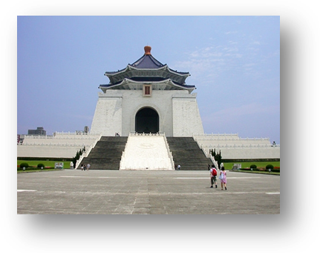 This memorial hall was built in memory of Chiang Kai-shek, the first president of the Republic of China. Work on the hall began in 1976, a year after President Chiang passed away. Design by C.C. Yang, who was also the architect for The Grand Hotel, the memorial hall is white with a blue roof, representing the dominant colors in the ROC flag; while the emblem of the Chinese Nationalist Party (KMT) adorns the vaulted ceiling. A bronze statue of Chiang looks west symbolically to the Presidential Office Building and mainland China. The front plaza of the hall is also a major venue for democratic assemblies.
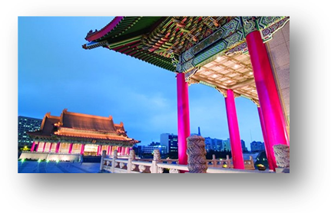The National Theater & Concert Hall located in the Boai District in central Taipei, the National Theater & Concert Hall (or the NTCH) features the traditional Chinese palace structure. The gold roofs, overturned edges, Chinese red colonnades and colorful arches demonstrate an elegant and imposing manner. The two buildings and the four adjacent plazas create an interesting and artistic living landscape, becoming one of the most significant landmarks in Taipei. The National Theater adopts the solemn hip roof shape, while the National Concert Hall is topped with the gable roof shape. While both designs were preserved for the royals in ancient times, now they welcome the public to come and admire with open arms. The architectural streamline drawn by the overturned edges of these majestic and classic national art sanctuaries inspires people to imagine the future on the basis of classicism.

- No.5─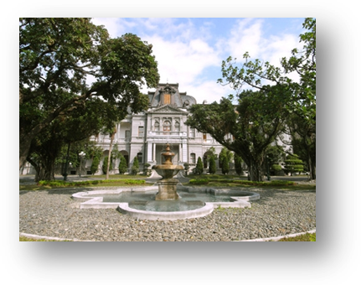Taipei Guest House
Construction of the Taipei Guest House began in 1899 and was completed in 1901. Its current form dates back a renovation in 1911. The guest house is located to the left of the Presidential Office Building and served as the residence of the governor-general during the Japanese occupation period. Visiting VIPs were also received here. In 1950, the building was renamed as the Taipei Guest House and repurposed for large state banquets, the reception of foreign dignitaries, and cultural activities. In 1998, the guest house was designated as a national historic site.

- No.5─Office of the President
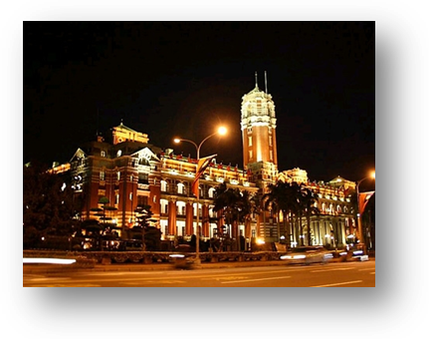The Presidential Office Building originally served as the seat of the colonial government during the Japanese occupation period. At the time of its completion in 1919, it was the tallest building in Taiwan. The east-facing structure looks out to Sishou Mountain and commands a panoramic view of the city. During the period of Japanese rule, 13 governors-general held office here. After Taiwan's retrocession, Chen Cheng installed the Southeastern Military Administrator's Office here. The building later served as the joint location of the Executive Yuan and Presidential Office before becoming the Presidential Office Building.

- No.6─The Installation Art Project: ‘Image of Ximen’
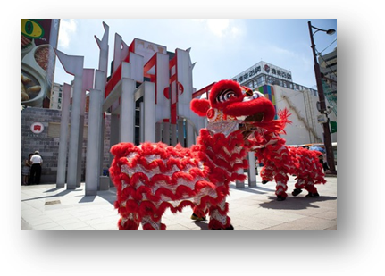 As its official Chinese name “Baocheng Gate” suggests, the supposedly wealth-attracting West Gate (a.k.a. “Ximen”) was a two-tier pagoda with up-tilted eaves. It was also the only one of Taipei’s five century-old citadel gateways that was demolished over time, in the early Japanese colonial period, to be precise. In an effort to reproduce the memories of the Baocheng Gate and mark the 130th Anniversary of Taipei City Walls, an installation project entitled “Impression of Ximen” was erected behind MRT Ximen Station (Exit 4) this year.
The Taipei City Wall was one of the last city walls to be built during the Qing period. Though only the gates survive, the original fortifications were extremely strong, with walls four meters thick five meters high and extending a total of four kilometers.
There are five historic city gates in Taipei: the East Gate (Jingfu Gate), West Gate (Baocheng Gate), South Gate (Lizheng Gate), Lesser South Gate (Chongxi Gate) and North Gate (Cheng’en Gate). They were built by Liu Ming-chuan during the reign of Emperor Guangxu in the Qing Dynasty as a measure to expedite urban development by encouraging businessmen to invest in or build houses/streets in Taipei City. Most Chinese walls have four gates, but the Taipei wall had five. Some say that the fifth gate—Xiaonanmen (Little South Gate)—was built especially for the convenience of the family of local tycoon Lin Pen-yuan in Banqiao, though this has never been proved.
Also known as Cheng’en Gate, the North Gate in erstwhile Taipei City served as a major gateway to Dadaocheng. The two-story fortress of North Gate is enclosed by sturdy walls in the form of a highly guarded citadel. For surveillance and defense reasons, the square- and round-shaped window openings on the front and back of fortress are the only two features on the second floor. Similar to the East Gate, the North Gate in its inception had a small enclosure on the outside, commonly referred to as “urn city”, or “Wong Cheng” in Chinese. There used to be a horizontal plaque saying “The Key to Territory Safety” which had hung across the gate. The plaque was unfortunately removed by Japanese colonial rulers and is now located on the empty lot in front of the North Gate for display.
In light of the emerging trend of cultural heritage preservation in recent years, the city authorities decided to abandon a demolition plan of the historic North Gate. Of the five ancient city gates, the North Gate is the only one that remains what it used to look like in the Qing Dynasty, as well as one of the most valuable state-designated historic sites in Taipei.
By geometrically deconstructing and then reconstructing Baocheng Gate, the designer of “Impression of Ximen” combined multiple frameworks and materials of varying heights and colors to provide a fresh insight into this historically glamorous neighborhood, and eventually bridge the gap between old and new.

- No.6─A Visual Journey of Discovery of Taipei City, Then and Now
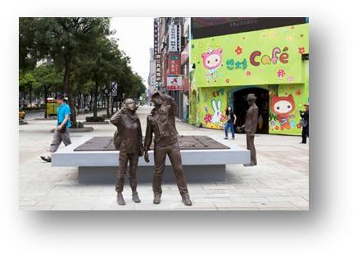 Taipei city wall was completed in 1884 at the time of the Sino-French War. Provincial Inspector-General Liu Ming-chuan came to Taiwan to oversee military and political administration and based himself in Taipei Walled City, where he supervised the building of government offices and schools, the laying of a railway, and opening of postal and telegram service in the city, laying down the foundation for its later development. After the Japanese gained control of Taiwan in 1895, Taipei City had its ups and downs and, from Retrocession in 1945 on, gradually become prosperous and the most important city in Taiwan.
The four sculptures were inspired by the people of past and present including Liu Ming-chuan, and planning, and provide a view of the development of Taipei Walled City. The streets of the walled city are carved into a relief sculpture showing the simple and beautiful landscape of the past.
It is well worth looking closely at the history of Taipei, our city.

- No.6─The Red House
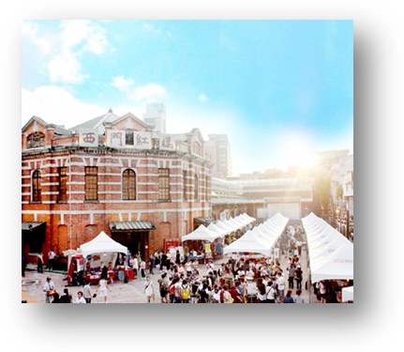The Red House, a Western-style red-brick octagonal structure in Taipei's Ximen space built in 1908, is Taiwan's first public market and the most well preserved class III historical site. Designed by Kondo Juro, a western-styled architect in the prefectural civil engineering office at the time, the market entrance, incorporating both octagonal and cruciform shapes, was paralleled by no other in the east and west. The market entrance also took on the ‘eight trigrams (bagua) design considered boldly creative then. Octagon Building, Cruciform Building, and the adjacent South-North Square are now collectively known as ‘The Red House.’
The Red House has established itself as a major location for the development of cultural and creative industry in the West End of Taipei City, given the 4 million-plus visits it has registered for the more than 1,000 arts- and literature-themed events it hosted throughout 2009. In 2010, the Red House launched, in its Cruciform Building, the Cradle of Cultural Creative Dreamer that is dedicated to incubating creative brands. Offering an exhibition platform for the cultural and creative industry, the Center refreshes the history-rich Red House look by connecting its creative spaces with the century-old Octagon Building.

- No.7─Nishi Honganji Square
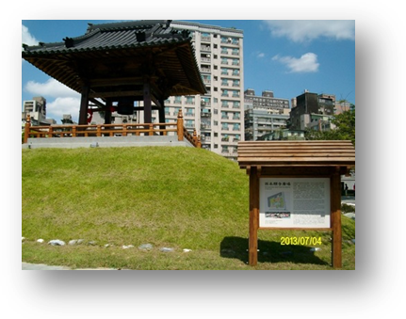 Located at the intersection of Zhonghua Road and Changsha Street in southern Ximending, a busy shopping district catering to young shoppers, Wanhua Plaza No. 406 occupies what used to be Nishi Honganji, a Japanese temple formally named “The Taiwanese Branch of Jodo Shinshu Honganji School.” Jointly constructed by Japanese and Taiwanese Buddhists from 1904 to 1912, this authentic Japanese-style building complex housed the Taiwanese chapter of a Shin, or Pure Land, Buddhism subgroup with most of its structures — the main hall, mausoleum, monks’ living quarters called “Kuri” and bell tower — designed in a Buddhist eclectic motif prevalent in 18th and 19th century Japan. The Rinbansho (quarters of a head priest), nevertheless, is a traditional Japanese residential structure and the Shuxin Hall (a.k.a., Tree Heart Hall) a modernist mix of bricks, European log cabins and Japanese roofing.
A series of government efforts have been made to renovate and reuse the culturally, historically and architecturally significant Nishi Honganji complex. Among others, the Nishi Honganji Square is transformed into an urban attraction and extension of the fashion-forward, buzzing Ximen neighborhood that lure shoppers to moments of nostalgia and memories, in hopes of bringing crowds back to the once-thriving Monga and recreating the area's former successes by attracting business interests.

- No.B─Heritage and Culture Education Center of Taipei:the historic Bopiliao area
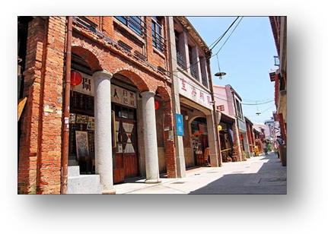 If you want to know more about Taipei’s history, the centuries-old street of Bopiliao offers a chance to experience the life of the old city first hand. Bopiliao Historic Block lies in the oldest developed district in Taipei City, Wanhua, which is located on the east bank of the Danshui River. It is one of the very few well-preserved historic sites in the city, dating back to 1799 when the name “Fupiliao” first appeared on a land deed in Wanhua.
By contrast, the meaning of the name “Bopiliao” seems frightening. In Mandarin, bo means to peel, pi means skin or surface, and liao is a type of hut or work station. People may wonder what kind of skins were peeled here in the old days, but according to Chang Chin-peng, director of the Heritage and Culture Education Center (HCEC) of Taipei City, the place has nothing to do with any horror scenes such as those seen in the movie The Texas Chainsaw Massacre.
Over the centuries, Taiwan experienced Qing-dynasty rule (1683–1895) and Japanese colonization (1895–1945), as evidenced by two contrasting architectural styles seen in Bopiliao. Nowadays, traditional Qing buildings can be found on the north side of this block, while the structures on the south side are mostly Japanese buildings.
Bopiliao Historic District contains abundant local culture, entitling itself to be the perfect place for heritage and culture education. A centuries-aged Lao-Song Elementary School is adjacent to the historic district which has been designated as land for school use in the land-use zoning plan since the Japanese Rule Era. A series of levy compensation had worked out from 1988 to June of 1999, the time when Taipei City decided "Conservation and Reutilization Policy of Bopiliao". As planed, Bopiliao was levied and reserved as a school land, and developed under the framework of cultural asset conservation and local culture education combined.
Renovation and Reutilization Project (Phase One) of Bopiliao Old Street East Part was approved by the urban design commission in October of 2002 and started construction in July of 2003. The Education Department of Taipei City Government established a Bopiliao reutilization operating team in August of 2003, named "Heritage and Culture Education Center of Taipei City (HCEC)" to incarnate the idea of "Educational ground roots in the historical street; the historical street.

- No.8─Longshan Temple
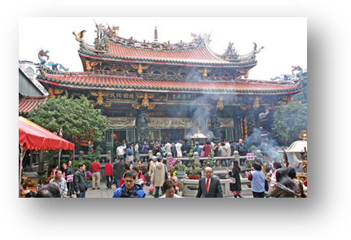 Longshan Temple is located in the district Manka of Taipei. It was founded in 1738 and dedicated to the Buddhist Goddess of Mercy (Kuan-in in Chinese, or Avalokitesvara in Sanskrit). This temple originated its name from the ancient Longshan Temple established in Chin-chiang county of Fukien province in the seventh century. Immigrants from the three counties Chin-chiang, Nan-an and Hui-an of Fukien came to Manka in the beginning of the eighteenth century. As they were pious followers of that ancient Longshan Temple in their home town, they erected this one as a branch temple at Manka and named it after the root temple when they created a new settlement here in Taipei. Longshan Temple of today is no longer in the original buildings constructed in 1738. It was rebuilt in 1919 and completed in 1924.
The Longshan Temple houses hundred of statues of Buddhist, Taoist, and Confucian deities. The temple mixes traditional Chinese siheyuan ("four-building courtyard") with palace architecture in its design. The temple is divided into front hall, main hall, rear hall, right wing and left wing. Painting of vivid creatures grace the temple walls, and stone statues of mystical creatures guard the temple grounds. The joining of wall and roof did not use any nails or braces made of metal. Covered by overtapping tiles, the temple roof is decorated with figures of dragon, phoenix and other auspicious creatures. The figures are decorated with porcelain, clay, and shards of colored glass. They represent the pinnacle of mosaic art in Taiwan. The temple has been declared a Secondary National Heritage Site.

- No.9─Riverside Bikeway
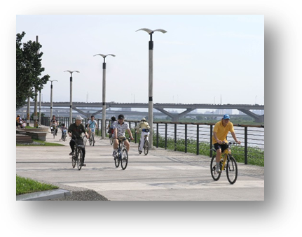Taipei City’s well-planned riverside bikeway system is complete with bike rental services for a 111-kilometer eco-trip that integrates the ecological and cultural resources along four rivers (Tamsui, Keelung, Xindian and Jingmei). While the stunning bio-diversity and riverside historic spots give visitors an opportunity to engage in leisure activities and see the City’s developmental phases, the waterfront belt running from Yuanshan, Dazhi to Neihu flaunts a new look after an extreme makeover. For example, the widened river reservation zone has become Keelung River’s crown jewel, offering city-dwellers a much-needed breathing space. Those who enter Dadaocheng through the Dadaocheng Evacuation Gate (D5) will also be impressed with the utterly romantic city lights glistening on both sides of Tamsui River.

- No.10─Dihua St.
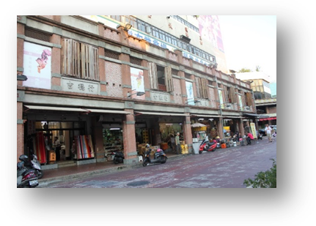 Dihua Street now is a pronoun of shopping for Chinese New Year’s fares. Located in the western part of Taipei City, Dihua Street is about 800 meters long and has developed since the mid of 19th century. Until Japanese Colonial Era in the end of 19th century, Dihua Street has become an important distributing and trading center for products such as Chinese medicine, herbs, fabrics, rice and tea due to it’s close location to Dadaocheng Wharf.
Because of Dihua Street’s profound history, many kinds of architectural styles such as Fujian style, western style and Baroque style can be found here. A walk through Dihua Street gives you a feeling of early days in Taipei City. Actually it is rather a quiet area in ordinary days. However, it will become surprising different a few days before Chinese New Year Eve. Thousands of people occupy the whole packed street and yelling from vendors can be heard all the time. Candy shops with colorful and mountainous candies always crowded with people. Besides, there are a variety of stalls selling handcrafts, snacks, dried squid, cooked food, decorations and any other goods related to Chinese New Year. With plenty of choices, the only thing you may need to concern is where to stop and try the food samples that vendors offer. Undoubtedly, Dihua Street is a perfect destination to experience the festival atmosphere during Chinese New Year in Taiwan.
 Going to Dihua Street is like walking into Taipei’s past. The moment you set foot onto the street, you’ll feel as if you’ve suddenly time-traveled to some point between the second half of the 19th century and the beginning of the 20th. Flashing skyscrapers and neon window displays? Not here. The architecture, store displays, smells, colors and the pace of life in this beautiful area and its surroundings will let you experience and learn a bit of Taiwanese history. We’ve listed some of the most charming attractions and our pick of interesting spots to help you make the most out of your visit. It’s the perfect place to take out-of-town visitors wanting to experience a bit of old school Taipei and a chance for them to pick up some unique items to take back home.

