On-line Visa Application Form:

How to fill visa application form on-line?

- Please go to the website to fill the form on-line:
https://visawebapp.boca.gov.tw

- Once you go to the website, you will see the main page as below:
Click on General Visa Application

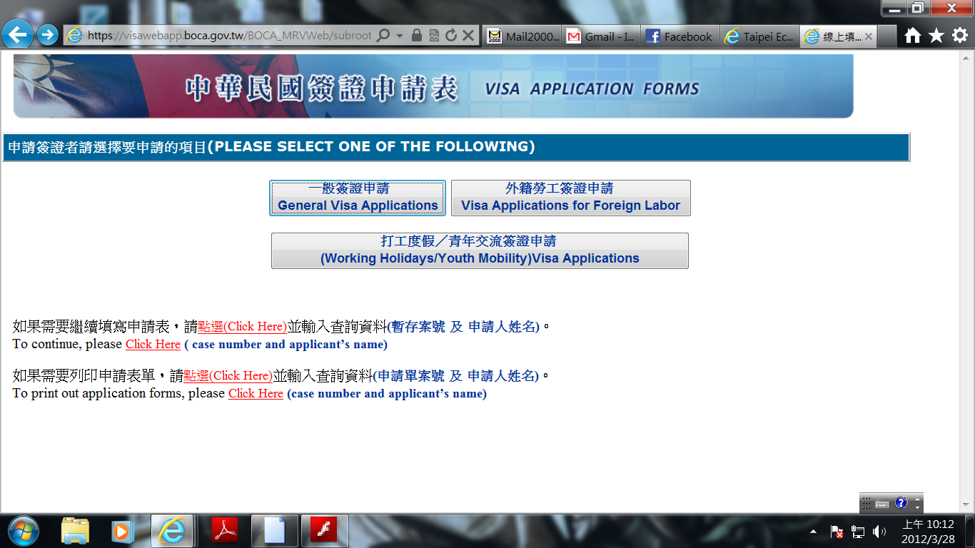

- Start to fill up the form,

Please note the location for visa application, choose Taipei Economic and Cultural Center in India

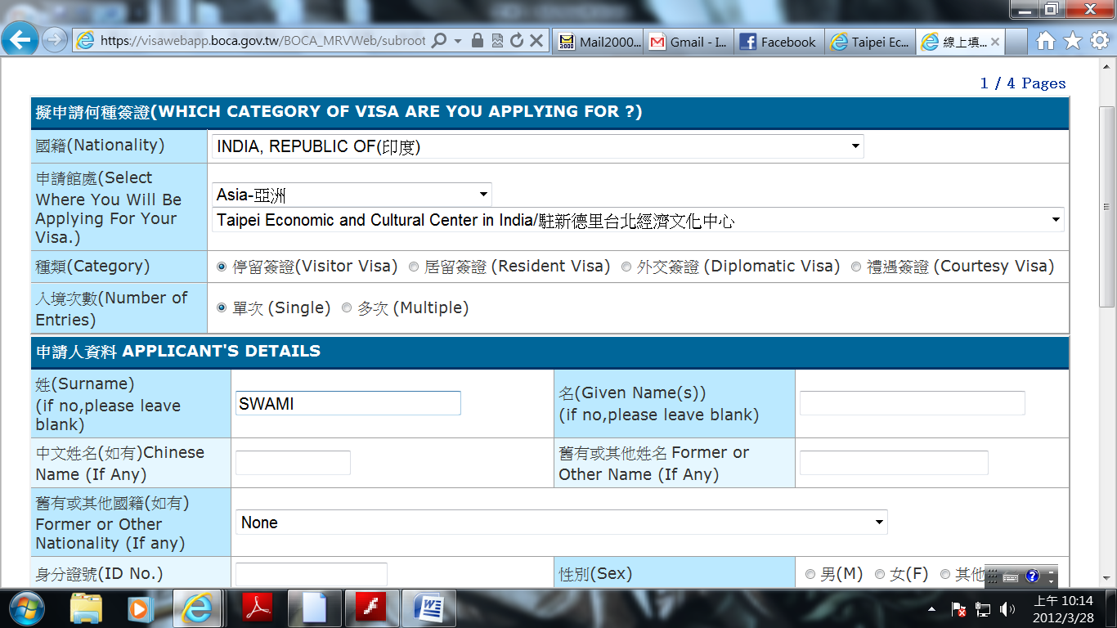

- Once filling up all the details please click on Next

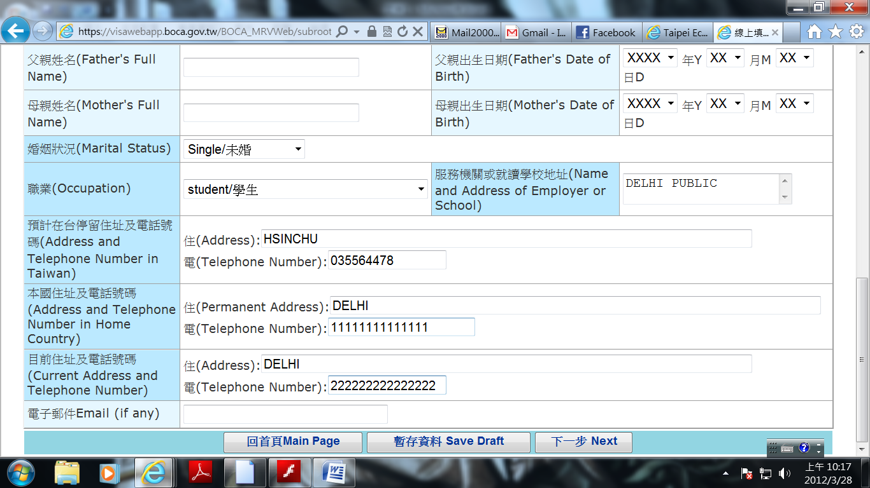
- Go to the following page, fill up the passport details and etc.

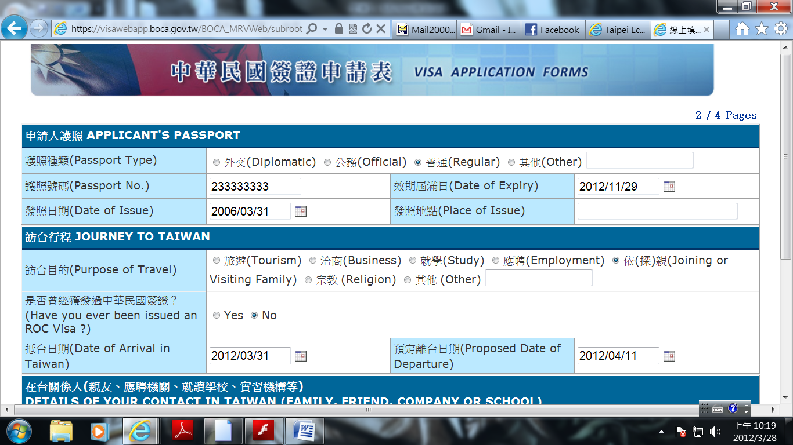

- Once filling up the contact person details please click on Next again,

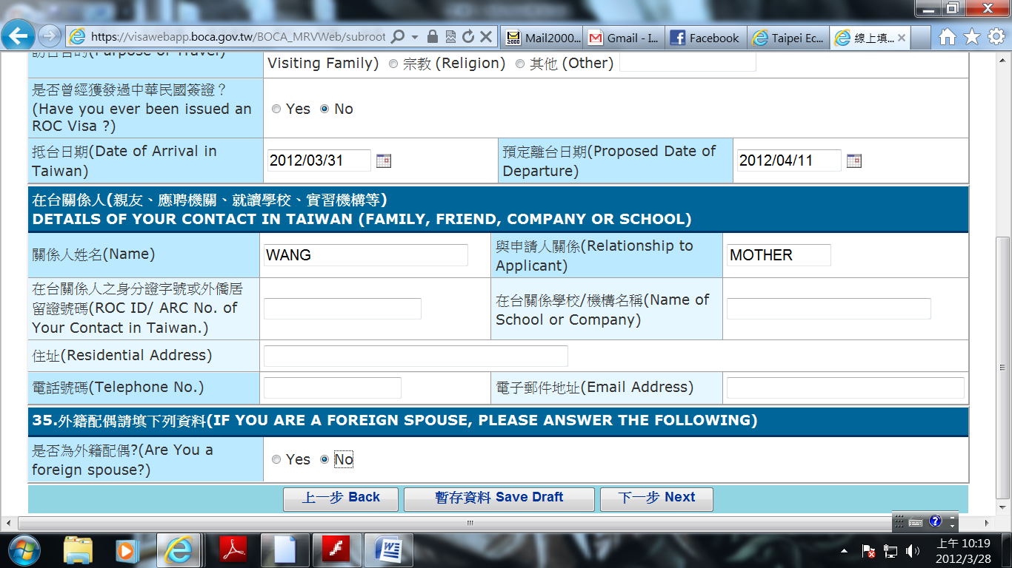

- The next page please choose the options as below, then click on Next,

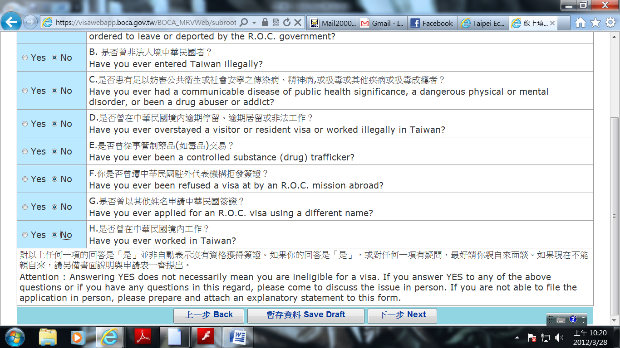

- The next page you will need to fill the application date and the agent’s details, if any,
then click on Submit,

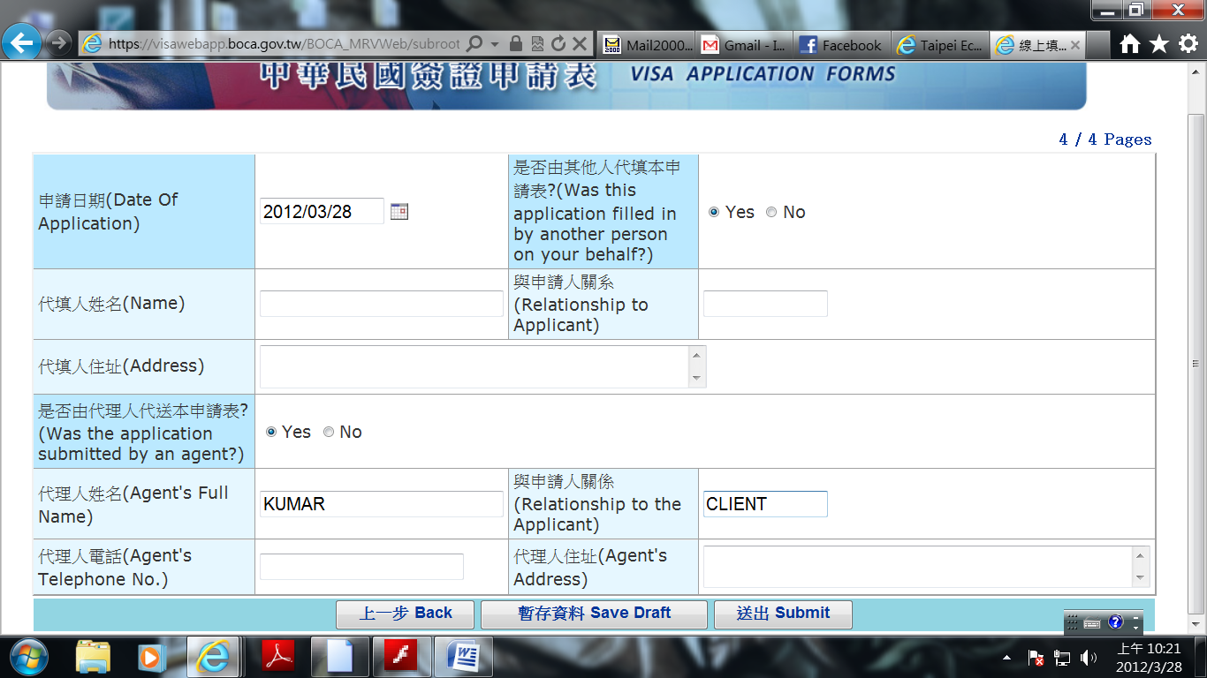
- Once you click on Submit, the page will come out one condition page, please click on
I Agree,

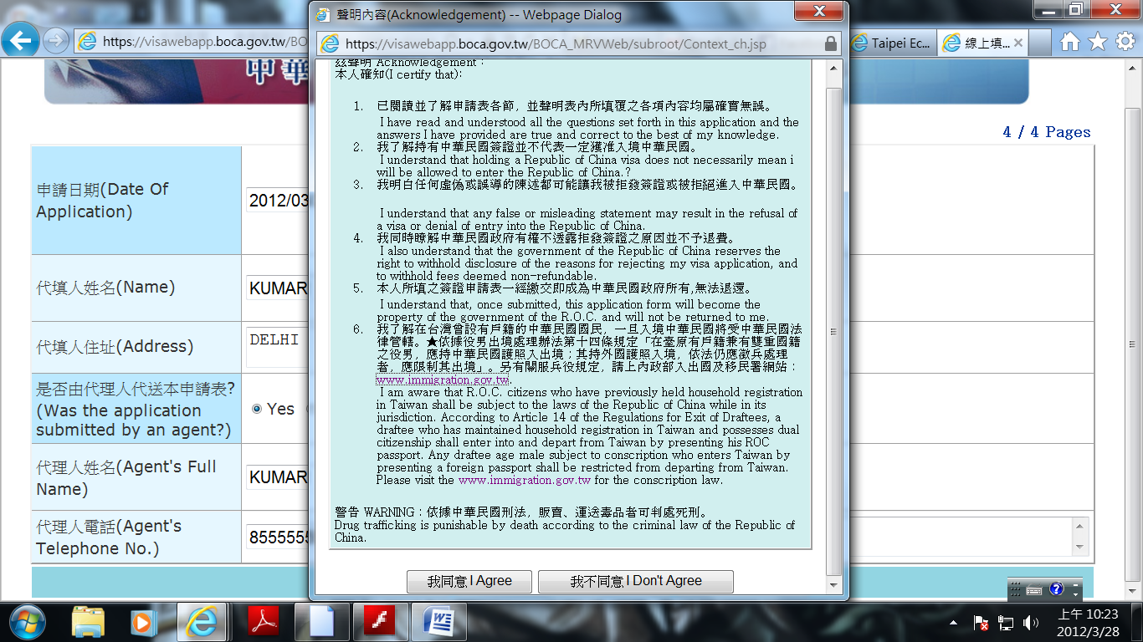

- Congratulations! You have completed the fill-up procedure,

You will find your Application No.in the next page, please click on Print Application Form

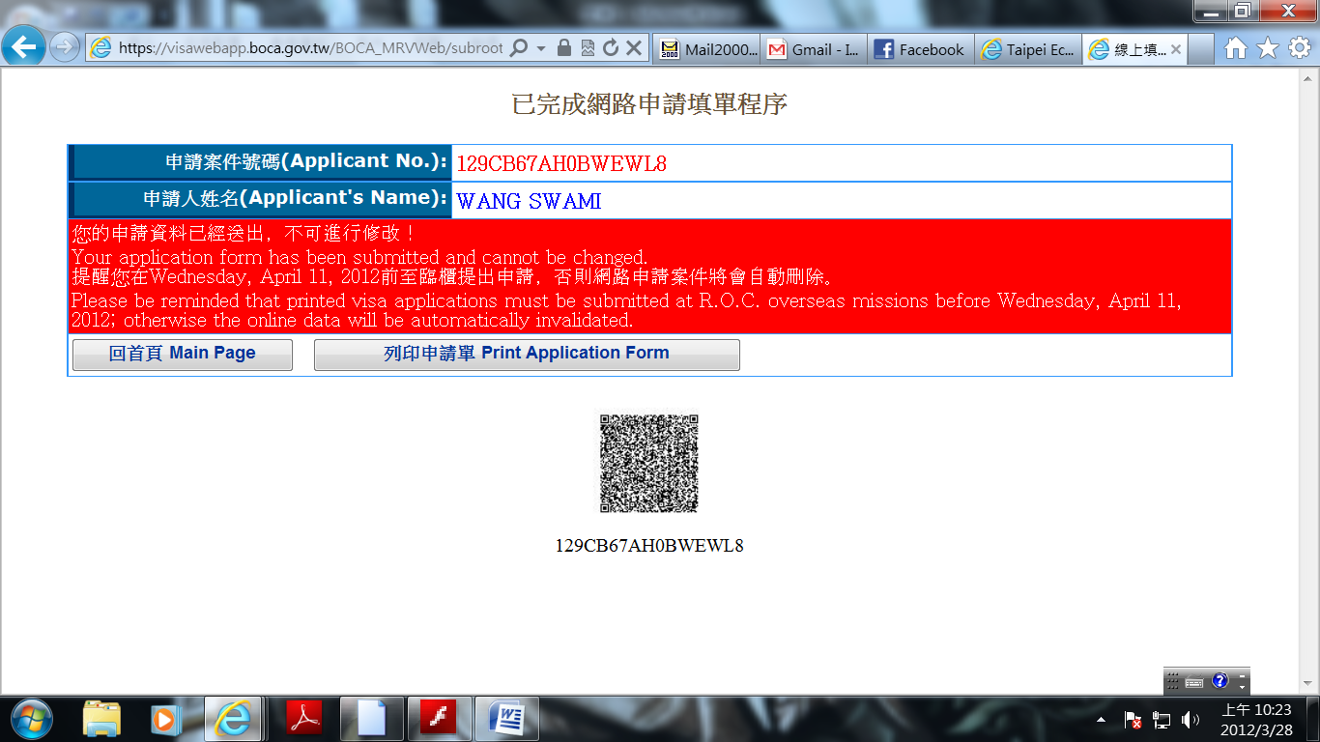

- Once you click on Print Application form, the system will automatically come out the PDF file of application form, just print it out,

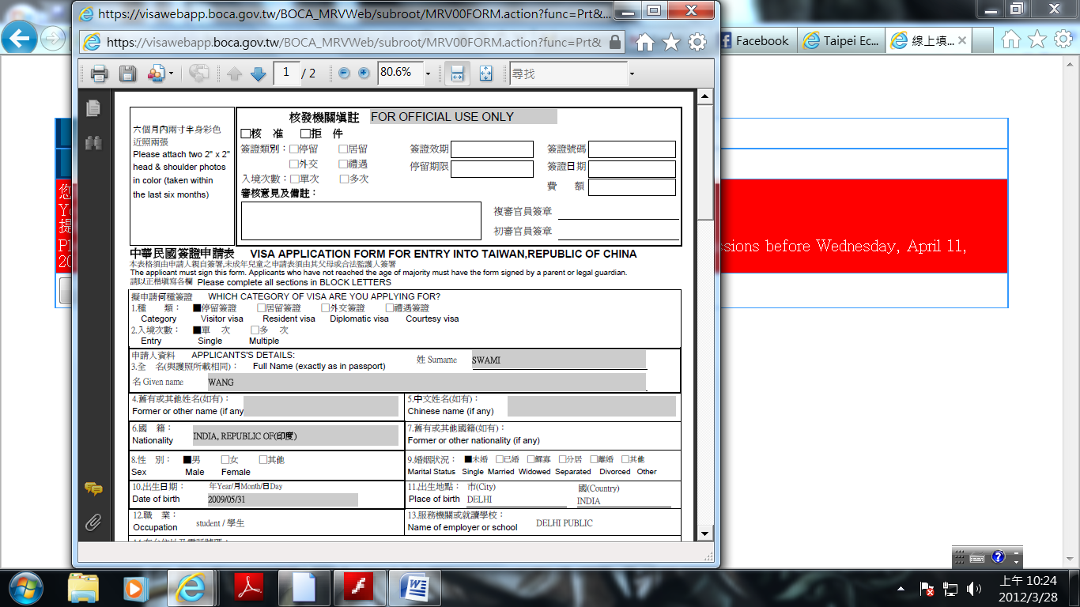

- The following visa application procedure is same as how we practice earlier, please carry this application form along with all the visa requirements when submitting your application.

- Thanks for the cooperation, in case you face any technical problem kindly contact our visa office.

Visa Division
Taipei Economic and Cultural Center in India
N-88, Panchsheel Park, New Delhi-110017
011-4607-7777

