文件驗證申請表
Authentication Service Request Form
請填寫以下資料 (Please complete the form):
1) |  | 2) |  |  | 3)
中文姓名 (Name in Chinese) |  |  | 外文姓名(Name in English) | 護照或台灣身分證號碼 (Passport or ID No.)
4) |  | 5)
手機號碼 (Mobile No) |  | 電郵信箱(Email address)
6)
郵寄地址 (Mailing address)
7) 勾選取件方式/時間(Collecting by): ☐ 臨櫃取件 (pick-up)
☐ 郵寄 (mail/courier)
☐ 一般件:收件後10個工作天可取件 (regular, 10 working days)
☐ 速件:加收提辦費收件後5個工作天可取件 (expedited, 5 working days)
8) 列出申請驗證的文件種類(內容)及份數 (Specify nature and amount of document for authentication):
- .
- .
附註說明(Reminder):
a. 驗證規費請以現金、郵局匯票或銀行支票支付，恕不接受個人支票或信用卡刷卡。
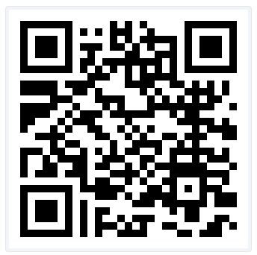
b. 辦理結婚證明或離婚判決，請註明結(離)婚生效日期:yyyy,mm,dd:
c. 倘如申辦法院判決離婚證明中譯文之驗證，中譯文請務必符合戶籍離婚登記之規定，如因不符合規定而無法完成戶籍離婚登記者，後果由當事人自理。(詳細內容請掃描右方QR-Code網頁說明)
d. 請詳實填寫各欄資料並繳驗身分證明文件，內容如有填寫不實或提供虛偽身分證件，申請人(及代理人)將可能觸犯中華民國刑法之偽造文書罪。
【In English:】
a. Please pay the fee in cash, money order or cashier check; We don’t accept personal check or credit card for payment.
b. To authenticate Marriage Certificate or Divorce judgment, please provide the effective date:
c. For the authentication of Chinese translation of a Divorce Judgment, the applicant is responsible to provide an explicit translation acceptable by Household Registration Offices.
d. The information provided and ID presented should be true and accurate. Any false/misleading statement or falsified ID presented will constitute an act of forgery under the Criminal Code of the ROC (Taiwan).
9) 申請人簽名/日期 (Requestor’s Signature / Date):
若非本人親自申辦，代理申請人請繼續填寫下列資料並提交身分證明及經公證之授權信；如有親屬關係，請提供親屬關係證明。(In English: Keep filling in if this request is submitted through an agent with ID and a notarized POA; Provide evidence of kinship if applicable.)
1.代理人中文姓名(Agent’s ChineseName): 2.外文姓名(Name in English):
3.與申請人關係(Relation to the Applicant): 4.電話(Tel. No.):
5.電郵信箱(Email): 6.代理人簽名(Agent’s Signature):
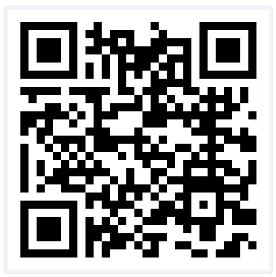
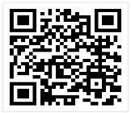
請掃描QR-code詳閱 Instructions for requesting
各類文件驗證申辦說明 authentication service

V20260722

