文件驗證申請表
Authentication Request Form
請填寫以下資料 (Please complete the form):
1. |  | 2. |  |  | 3.
中文姓名 (Name in Chinese) |  |  | 外文姓名(Name in English) |  | 護照或台灣身分證號碼 (Passport or ID No.)
4. |  | 5.
手機號碼 (Mobile No) |  | 電郵信箱(Email address)
6.
郵寄地址 (Mailing address)
7.勾選取件方式/時間(Collecting by): ☐ 臨櫃取件 (pick-up)
☐ 郵寄 (mail/courier)
☐ 一般件:收件後10個工作天可取件 (regular, 10 working days)
☐ 速件:加收提辦費收件後5個工作天可取件 (expedited, 5 working days)
8.列出申請驗證的文件種類(內容)及份數 (Specify nature and amount of document for authentication):
- .
- .
附註說明(Reminder):
a. 驗證規費請以現金、郵局或銀行匯票支付，恕不接受個人支票或信用卡刷卡。
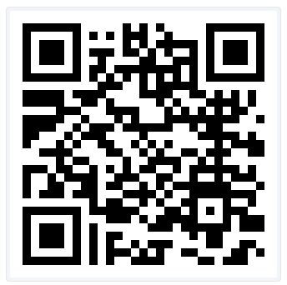
b. 倘如申辦法院判決離婚證明中譯文之驗證，中譯文請務必符合戶籍離婚登記之規定，如因不符合規定而無法完成戶籍離婚登記者，後果由當事人自理。(詳細內容請掃描右方QR-Code網頁說明)
c. 請詳實填寫各欄資料並繳驗身分證明文件，內容如有填寫不實或提供虛偽身分證件，申請人(及代理人)將可能觸犯中華民國刑法之偽造文書罪。
【In English:】
a. Please pay the fee in cash, money order or bank check; We don’t accept personal check or credit card for payment.
b. For the authentication of Chinese translation of a Divorce Judgment, it’s the responsibility of the applicant to provide an explicit translation acceptable by Household Registration Offices.
c. The information provided and ID presented should be true and accurate. Any false/misleading statement or falsified ID presented will constitute an act of forgery under the Criminal Code of the ROC (Taiwan).
9.申請人簽名/日期 (Requestor’s Signature / Date):
若非本人親自申辦，代理申請人請繼續填寫下列資料並提交身分證明及經公證之授權信；如有親屬關係，請提供親屬關係證明。(In English: Keep filling in if this request is submitted through an agent with ID and a notarized POA; Provide evidence of kinship if applicable.)
1.代理人中文姓名(Agent’s ChineseName): 2.外文姓名(Name in English):
3.與申請人關係(Relation to the Applicant): 4.電話(Tel. No.):
5.電郵信箱(Email): 6.代理人簽名(Agent’s Signature):
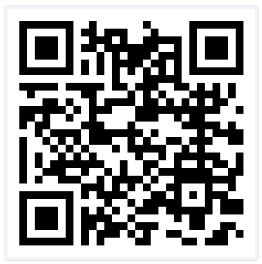
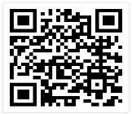
掃描QR-code 可詳閱 Instructions for requesting
各類文件驗證申辦說明 authentication service

V20260620

