Ambassador Ray H.W. Mou

Republic of China (Taiwan)
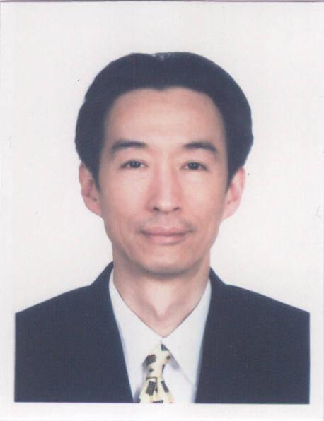
Ambassador Ray H.W. Mou
Year of Birth: 1960
Diplomatic Career

- Representative, Taipei Commercial Representative Office in the State of Kuwait 2017—Present
- Ambassador to Saint Lucia, September 2015.---2017
- Director-General, Department of NGO International Affairs, Ministry of Foreign Affairs (MOFA), March 2014- September 2015.
- Deputy Director-General, Bureau of Consular Affairs, MOFA July 2013 –March 2014.
- Director-General, Taipei Economic and Cultural Office in Miami, September 2010 – April 2013.
- Deputy Representative, Taipei Representative Office in the UK, October 2006 - September 2010.
- Deputy Secretary-General, Coordination Council for North American Affairs, January 2005-July 2007.
- Special Assistant to Foreign Minister, 2003-2006.
- Deputy Director of Political Affairs Division, Taipei Economic and Cultural Representative Office in the USA, June 2000- July 2003
- Section Chief, Department of International Cooperation and Economic Affairs, MOFA, May 1996-October 1997.

