“Credit Guarantee Fund of Mongolia” /hereinafter CGFM/ is the financial organization established by the Mongolian government in 2012. The purpose of CGFM is to assist SME financing by private financial institutions such as banks by guaranteeing loan repayment through credit assessment for the enterprises lacking sufficient collaterals.
Mission of the Fund
“Contribute to Mongolia’s economic growth through prompt, transparent and reliable services.”
Objectives of the Fund
-To provide credit guarantees for SMEs;
-To create and maintain jobs;
-To ensure a stable income for the general public.
Our guiding principle
The fund will adhere the guiding principles of ensuring the equal participation and good governance without conflict of interest.

- Major Operations: Indirect Guarantees
- Outstanding Guarantee: MNT 25.9 billion (as of 2017)
- No. of Employees: 34
- Biz netowrk: 1 Head office
Guarantee coverage ratio:
Up to 60 percent of credit per applicant and maximum guarantee amount is 500 milion MNT per credit.
Guarantee period:
Shall not exceed the term of the loan agreement.
Guarantee fee:
Guarantee fee will be charged once based on the credit duration.
Up to 1 year – 1%
Up to 2 years – 2%
Longer than 2 years - 3%
Credit guarantee eligibilty:
  - Must be Small and Medium Sized Enterprise (Law on SME, Clause 5.1)
  - No overdue loan or debt occurred within 6 months.
  - Not engaged in prohibited activities.
  - Must have insufficient collateral.

Issued Guarantee /in billion MNT/
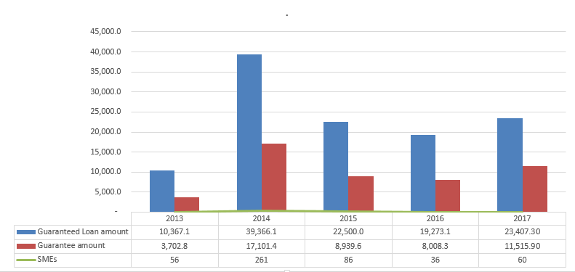
In our 5 years of operation we have issued around 49.2 billion MNT guarantees worth of 114.9 billion MNT loan and have around 25.9 billion MNT outstanding guarantees worth of 59.3 billion MNT outstanding loan for 275 SMES as of the end of 2017.

Number of employment sustained
Jobs/Date | 2013 | 2014 | 2015 | 2016 | 2017 | Total
Sustained | 506 | 1908 | 797 | 665 | 1274 | 5150
Created | 212 | 878 | 286 | 163 | 471 | 2010

One of the objectives of our Fund is to generate and maintain the employment which further supports the country’s economy. According to the year end report the CGFM has achieved to maintain 5150 jobs and generate 2010 jobs in total.
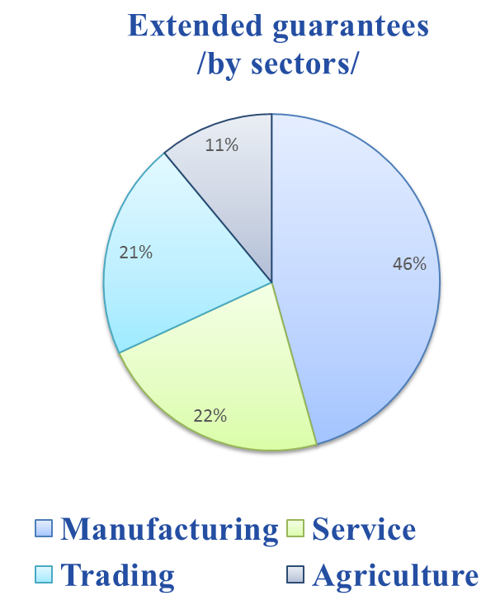

As of the end of 2017, extended guarantees for manufacturing sector occupied 46%, ranking first among other sectors. The service sector accounted for 22%, ranking the second. The Trading and Agriculture sector represented 21% and 11% respectively.

Legal environment and supervisory
Laws and resolutions
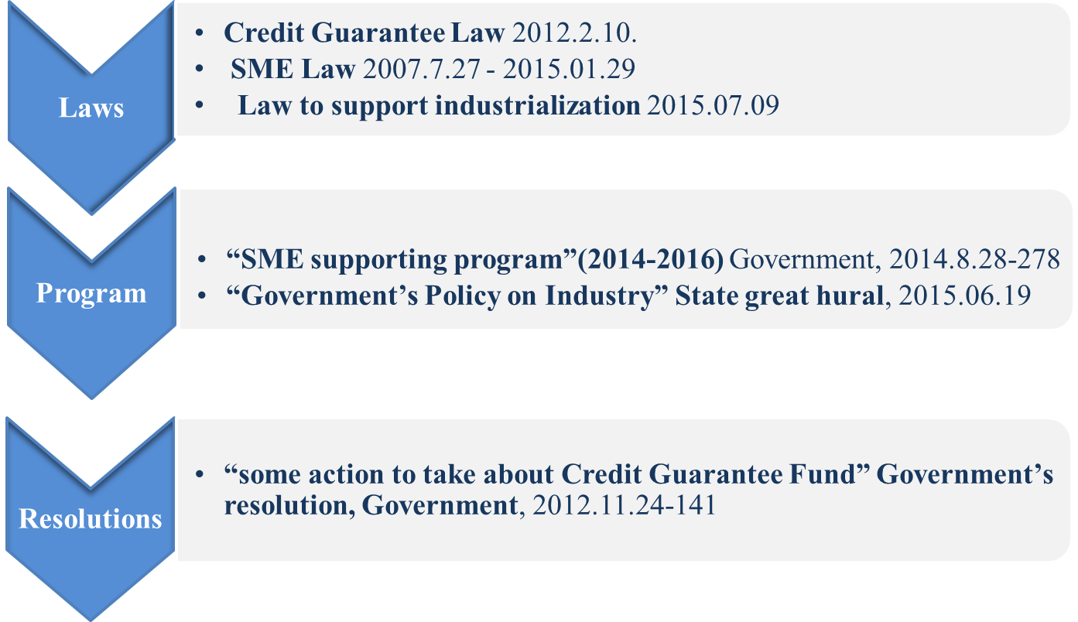

Observing Laws, policies and regulations of CGFM

- Law of Mongolai on Credit Guarantee Fund
- Law on Government Special Funds
- Corporate Income Tax Law of Mongolia
- Law of Mongolia on Violations
- Law on SME of Mongolia
- Fund charter
- The regulation on monitoring and setting prudential ratio for CGFM’s operation by Financial Regulatory Commission of Mongolia
- Regulation on managing and placing the capital and monetary asset of CGF
- Regulation on guarantee type, size, period, commission, fee nd other conditions
- Guarantee regulation
- Guarantee policy
- Risk management policy
- Registration and information keeping regulation
- Regulation on cooperation with banks and financial institutions
- Regulation on subrogation
- Law on banking transactions
- Guideline on collecting non-performing loans

Supervision of CGFM
Monitoring scheme of Credit Guarantee Fund of Mongolia and Guaranteed loan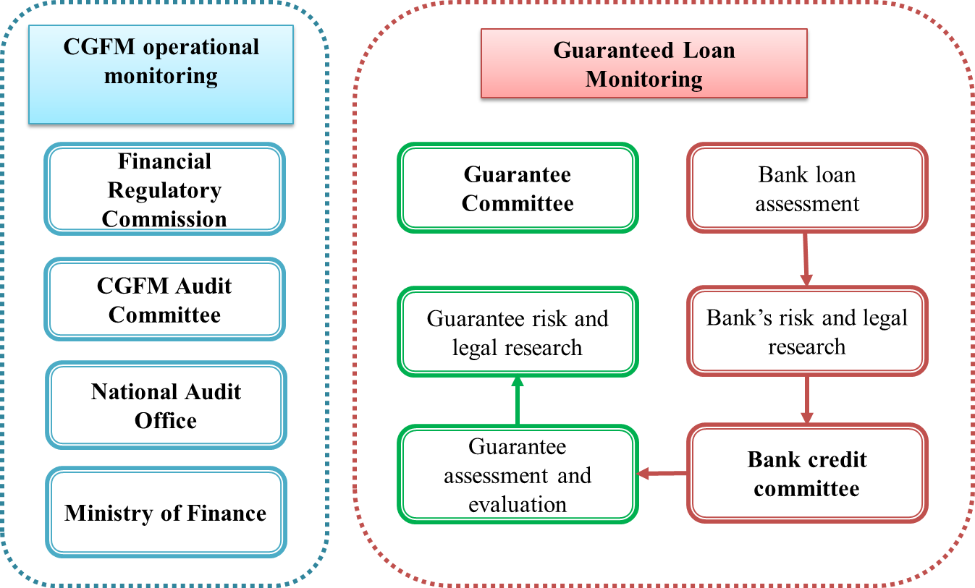
Cooperation of CGFM
Foreign
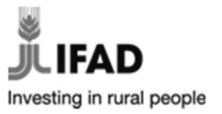
As of 2017, the CGFM is cooperating with above foreign Credit Supplementation Institutions under MoU.
- Asian development Bank
- Korea Credit Guarantee Fund
- Taiwan SMEG
- Credit Guarantee Corporation Malaysia Berhard
- JICA – Japan International Cooperation Agency
- IFAD – International Fund of Agricultural Development
- Credit Fund of Moscow
Domestic
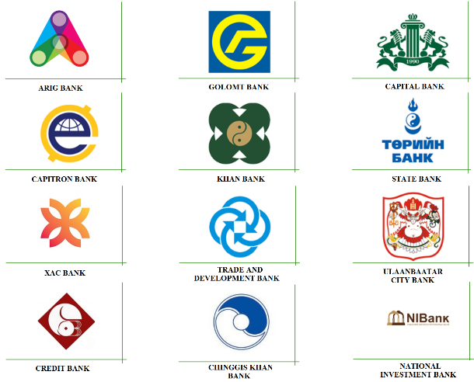
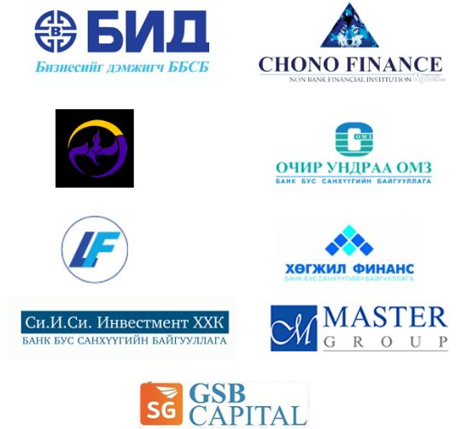
Non banking institutions
Banks

