2022 TOCFL Test at TEC-SRMIST Schedule
1. Date: 26th November 2022 (Sat.)
2. Time:
>Novice level: 10am-12pm
>Band A level: 13.30pm-15.30pm
(Please attend the venue 10 mins before test time.)
3. Deadline: 5pm, 23rd September (Fri.)

4. Venue: Taiwan Education Center-SRMIST
(Room1107, 11th floor, University Building, SRM Institute of Science and Technology, Kattankulathur, Chennai, India 603203)

5. Fees:
>Novice- Rs.1500
>Band A-Rs.2000
(Only Listening and Reading Test in Novice and Band A level)

6. Payment information:
Account Number: 9180-1007-2229-164
Account Holder: LING YUN TSAI
Bank: Axis Bank LTD
Branch: MARAIMALAI NAGAR
IFSC: UTIB0003393
Swift Code: AXISINBB428

(Must pay before 5pm on 23rd September.)
(Please note the name and take screenshot. Email the payment screenshot & name to “ tecsrm@gmail.com ” to secure your seat.)
(Email subject: 2022 TOCFL test fee + Name)

7. Test Result: Will be sent to the address mentioned in the form.
8.More information about TOCFL test, please visit
>> https://tocfl.edu.tw/index.php/home/index
9. Should you have any doubt, please write the email to “ tecsrm@gmail.com”

Registration form - https://forms.gle/4y8YpsnzkP4fJYUP8
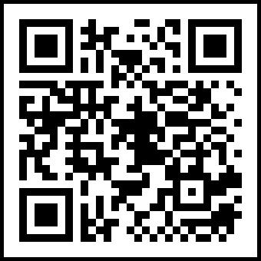
QR code-

