Stanley KAO  Representative  Taipei Economic and Cultural Representative Office (TECRO), Washington, DC, U.S.A. | 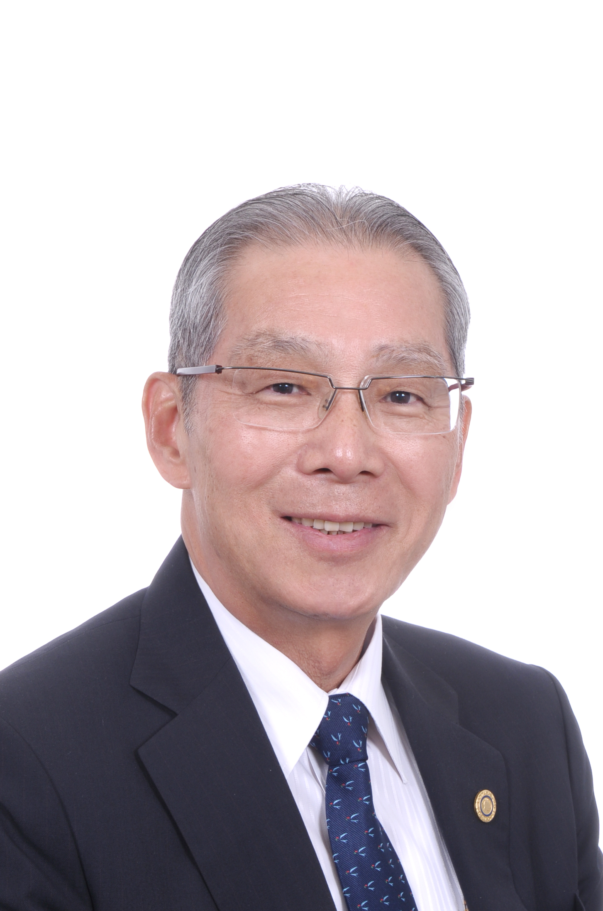

Ambassador Stanley Kao assumed his current position as TECRO Representative in June 2016. Prior to that, he served as Taiwan’s Representative to Rome, Italy from 2013 to 2016. In his 40-year foreign service career, he has served as Director General of the Department of North American Affairs (2001-02) and of International Cooperation and of Economic Affairs (2010-13) at the Foreign Ministry in Taipei; Head of Taiwan’s Mission to Budapest, Hungary (2008-10); Deputy Chief of Mission in Washington, DC (2004-07); and Deputy Permanent Representative of Taiwan’s delegation to the WTO in Geneva, Switzerland (2002-04). He was the English interpreter for Presidents Chen Shui-bian and Lee Teng-hui. He was also posted in Kuala Lumpur, Malaysia (1996-98) and in Atlanta, Georgia (1993-96).

Amb. Kao holds a B.A. in Political Science from National Taiwan University, and an M.A. in International Law and Diplomacy from National Chengchi University in Taipei. He was also a Visiting Fellow at Harvard University’s Weatherhead Center for International Affairs (WCFIA) in 1996-97.

Amb. Kao is a proud Rotarian and a big fan of tennis, golf and baseball. He and his wife, Sherry Sung, are the proud parents of one daughter.

