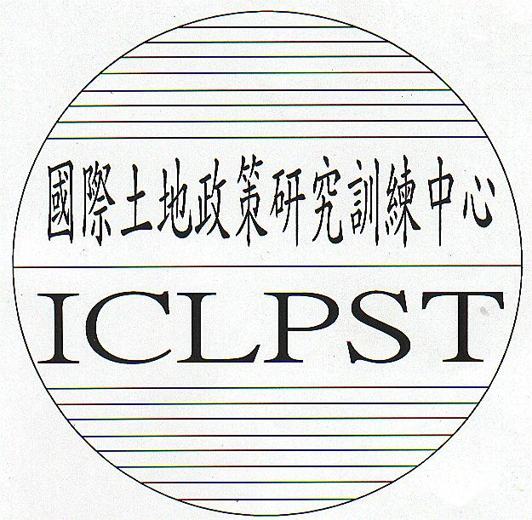 | INTERNATIONAL CENTER FOR  LAND POLICY STUDIES AND TRAINING

APPLICATION FORM | 574 Chungshan Road  Taoyuan District, Taoyuan City, Taiwan, ROC  Tel.: (Int.+886)-3-3324622  Fax: (Int.+886)-3-3364397  E-mail: iclpst@iclpst.gov.tw
Course: The 134th Regular Session on Land Taxation and Valuation

Please Note:
1. | Candidates with poor rating in spoken and written English will not be considered.
2. | Candidates must be persons who are presently working in the areas related to the subject matter of the session.
3. | All sections of the application form must be completed (typed out).
PHOTOGRAPH
Section A (To be completed by applicant) (Please Type or Print)
1. | Name:
 |  |  | First(Given) |  |  |  |  |  |  |  |  | Middle |  |  |  |  | Last(Surname)
 | Name in Chinese if any:
2. | Title: | Mr. □ Mrs. □ Miss □ Other □
3. | Nationality:
4. | Date of Birth:(mm/dd/yy)
5. | Gender: |  |  |  | M □ F □
6. | Marital Status: |  |  |  |  |  | Single □ Married □
7. | Religion:
8. | Dietary Restriction:
9. | Passport Number:
 | Date of Issue:(mm/dd/yy) |  |  |  |  |  |  |  |  |  |  |  |  |  | Date of Expiry:(mm/dd/yy)
10. | Home Address:
 | Tel.: Country Code: |  |  |  |  |  |  |  |  |  |  |  | No.:
 | Fax: Country Code: |  |  |  |  |  |  |  |  |  |  |  | No.:
 | E-mail:
11. | Training Abroad:

12. | Education Background
 | Degree |  |  |  | University or College |  |  |  |  |  |  |  |  |  | Subjects |  |  |  | Graduation Date
13. | Employment and Work Experience
 | Name of Office:
 | Current Position:
 | Description of Work and Responsibility:
 | Address:
 | Tel.: Country Code: |  |  |  |  |  |  |  |  |  | No.:
 | Fax: Country Code: |  |  |  |  |  |  |  |  |  | No.:
 | E-mail:
14. | Previous Work Experience:
15. | Reasons for Participation:
16. | Signature: |  |  |  |  |  |  |  |  |  |  |  |  |  |  | Date:(mm/dd/yy)

Section B (To be completed by Head of Institution or Department)
1. | Assessment of Applicant:
 | Level of spoken English: |  |  | Poor □ Fair □ Good □ Very Good □ Excellent □
 | Level of written English: |  |  | Poor □ Fair □ Good □ Very Good □ Excellent □
 | Any additional languages spoken other than native language:
2. | I recommend / do not recommend the candidate
 | Recommending Authority:
 | Name: |  |  |  |  | Title:
 | Signature: |  |  |  |  | Date:

Section C (To be completed by ROC Embassy or Representative Office)
I recommend / do not recommend the candidate
Officer-in charge: |  |  |  | Title:
Signature/Official Stamp: |  |  |  | Date:
Comments:

